

An Experimental

Environment to Test a

Theory of Play

236807

Informatics

Computer Science

Professor Peter Cheng

May 2022

Word Count: 11,321

Statement of Originality

This report is submitted as part of the requirements for a degree in Computer Science at the University of Sussex. It is the product of my own labour, except where noted in the text. The report may be freely copied and distributed, provided the source is acknowledged. I hereby give permission to lend copies of this report to students in future years.

Acknowledgements

I would like to thank Dr Peter Cheng for his immeasurable contribution, patience and guidance. I would also like to thank the participants who volunteered to take part in my experiments for their patience in completing them and for providing me with a wealth of experimental data.

Abstract

This project aimed to investigate how the number of options in a game affects player engagement. A variant of the snake game based on Unity was provided as an experimental environment for players to play and collect feedback on their engagement in the game. 24 participants participated in the experiment, and their actions in the game were automatically recorded and uploaded to the server. The results showed that people's engagement with the game increased as the number of options increased, but only within a specific range of options. The reasons for the decrease in engagement are also presented in this report.

This report details the design and development process of the experimental environment inspired by the snake game and the analysis of the results. It also includes an appendix of professional and ethical issues that may have arisen during the conduct of the project.

The game used for the experiment is running online and can be accessed via the link below: <https://play.unity.com/mg/other/snake-webgl>.(The game will no longer record user data.)

Table of Contents

1. Introduction 5

1.1 Problem Space 5

1.2 Background Research 6

1.2.1 Game Engagement 6

1.2.2 Snake Game Inspired Games 8

1.2.3 Range of Options 9

1.2.4 Unity 10

1.2.5 Data Collection and Analysis 10

2.Professional Considerations 11

2.1 BCS CODE OF CONDUCT 11

2.1.1 Public Interest 11

2.1.2. Professional Competence and Integrity 12

2.2 Ethical Review 12

3. Program Objectives 14

3.1 Project Aims and Objectives 14

3.1.1 Primary Objectives 14

3.1.2 Extensions 14

3.2 Requirements 15

3.2.1 Snake-inspired Game Requirements 15

3.2.1.1 Functional Requirements 15

3.2.1.2 Domain Requirements 16

3.2.2 The experiment Requirements 16

3.2.2.1 Functional Requirements 16

3.2.2.3 Domain Requirements 16

3.3 Preliminary design 17

3.3.1 Directional options 17

3.3.2 Game flow 18

3.3.3 Class Diagram 20

4 Implementation 21

4.1Snake Game 21

4.1.1Snake Movement 21

4.1.2 Snake ate Food 23

4.1.3 Game Over 24

4.1.4 Multiple Direction 25

4.1.5 Usability User Testing 27

4.2 Experimental interaction screens 27

4.2.1 Introduction and Declaration 27

4.2.2 questionnaire screen 28

4.2.3 Main Menu Screen 29

4.2.4 Main Game Screen 30

4.2.5 End Questionnaire Screen 34

4.2.6 End Screen 35

4.3 Uploading and recording data 36

5. Experimentation: Methodology 39

6. Experimentation: Data Analysis and Discussion 40

6.1 Data Analysis Methodology 40

6.2 Key Findings 40

6.3 Additional Findings 45

7. Project Conclusion 46

8. References 47

9. Appendix 50

# Introduction

### 1.1 Problem Space and Experimental Environment

Video games are a prevalent leisure activity. Consumers spend more time on games than ever before [1], but what makes it fun and keeps people focused throughout the game? Great controls, smooth movement and frame rate, excellent level design, and stunning graphics make the game stand out for the player. [2] But if we look through the game to its essence, we find that a good game is actually made up of a series of interesting choices. [3] What options make a game more engaging, or how many decisions make the player more engaged in the game? It is both an exciting and challenging question for me to answer regarding the intrigue of video games in our lives, so I designed an experiment to explore the theories behind the games.

This project is an experiment to investigate the link between choice and player engagement in games, i.e., fluctuations in user engagement with changes in the number of options; reasons for changes in user engagement. I need to design a game where making choices is the essential action, have users play the game, devise a way to detect user engagement, and record experimental data from users in the game.

I chose to use a variant of the classic Snake game as my test environment. In the Snake game, the snake is faced with 3 options for each move until the player guides the snake to a food location, all the player has to do is to control the snake in a two-dimensional plane by constantly turning to avoid hitting walls and itself, a process that can be seen as a series of choices. We can trace Snake's design back to the arcade game Blockade [4]; we now know it as a revised version released on Nokia mobile phones in 1997. [5] The player uses the arrow keys to control a long snake that keeps swallowing beans, and the snake's body keeps getting longer as it eats beans. The game ends when the snake's head touches the snake's body or an obstacle.

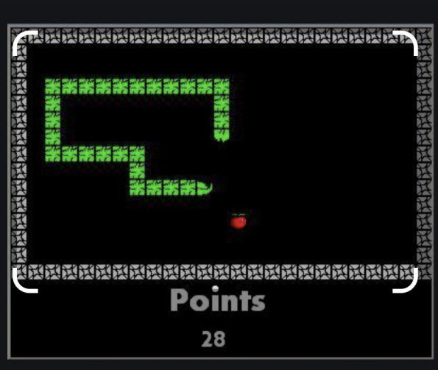

*Figure 1 – Traditional Snake Game*

### In my experiment, the game has been adjusted so that the snake moves in more or less than four directions; there are seven different rounds with the number of directions ranging from 2 to 8. The player needs to control the absolute direction of the snake (board based) using the keys corresponding to the direction of the snake's movement. Some minor changes (discussed in 1.2.3 Range of Options) have been made to the key settings so that these actions do not interfere with the player's control of the game.

This report describes how I tested the theoretical implementation of the game options using a Snake game-inspired game as an experimental setting. The experiment's final results indicate that people's engagement with the game is positively correlated with the number of options under certain circumstances. However, players' engagement decreases when there are too many options to choose from.

### 1.2 Background Research

### The following section describes the background research I have done for this project, and my motivation for doing this experiment.

### 1.2.1 Game Engagement

Despite the lack of research on game choices, there is considerable research on how a game's challenge affects players' engagement. In "What makes games so engaging?"[6] Amy Jo Kim talked about the meaning of game engagement, and the game mobilizes our brains to become proficient in skills gradually. We make more progress toward mastery as the challenge increases. The game involves a series of choices and challenges on the path to mastery as well as progress indicators (points, badges, levels, leader boards, reputation systems). As an independent system, these markers can help you gauge where you are and how far you have come, but they are worthless. Therefore, we need to let players develop new skills in the game. The diagram(Figure 2 [6]) below shows that when the player's skills and the game's challenge reach a certain level, the game's attractiveness becomes higher. From the diagram we can see that as the player's skills improve along with the challenge, there is a gap that makes the experience somewhere between anxiety and boredom for the player. This is the balance point of the game experience and only by finding this balance between the difficulty of the game and the skill of the player will the game be more engaging.

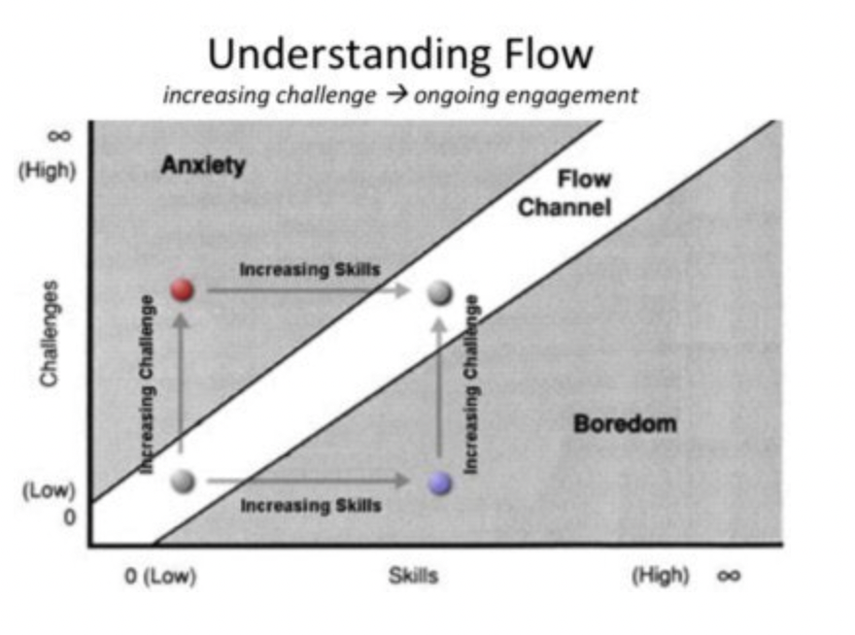

*Figure 2 – The skill development and challenge increase chart*

Furthermore, according to Marco C. Rozendaal's study of game features on game engagement, they mention that increasing the number of game features can attract players and develop new knowledge, [7] these features can be in the form of visuals, the amount of media or the freedom of game manipulation. One of these is the freedom of game manipulation, which is a large range, and it is difficult to define how the freedom of game play can be changed through human manipulation. However, according to Averill (1973) [8] the delineation of decisional behaviour plays an important role here, with Averill defining decisional control as the range of choices or number of options available to an individual. If the number of options or the complexity of options in a game is seen as the degree of freedom the game gives to the player, then it is likely that the player's involvement is related to the options in the game.

The options in the game are a factor in the freedom of the game, and the complexity as well as the number of options will also challenge the player to some extent. When there is a positive correlation between the challenge the player faces and their current skill, the player will, as shown in Figure 3, have some sort of functional relationship, with the player's skill increasing as the challenge increases and the player's engagement increases. One way to increase the challenge of the game is to increase the number of options in the game, increasing the degree of freedom the player has in controlling the game. If the player's skill also increases as the number of options increases, then engagement will increase, but when the player's skill does not keep up with the challenge of the game due to the increase in the number of options, then the player is likely to become less engaged and feel bored or anxious.

### 1.2.2 Snake Game Inspired Games

As my experiment was built on the snake game, I needed to select a version of the snake game to use as the basis for my building experiment. Historically Snake was developed as an arcade game by Gremlin Industries, Inc. and released by Taito Corporation [9], and since then there have been dozens of different versions of the Snake game that have been created. I chose to use Google's 2017 release of Snake with Google Chrome support as the basis [10], which is similar to the original, except that it is a standalone version of Snake, with only the basic direct control of the snake's movement with the arrow keys.

Snake game is attractive as an arcade game because of its intuitive visual feedback-every time the snake eats an apple, the snake's body will grow a bit; the second is that the game's difficulty will increase with time it takes to play. The third is that your score will be reported at the end of the game based on the time you have survived and the number of apples eaten. After each round, people constantly want to surpass the previous score; this seems to be a good thing. Still, as the player's proficiency increases, the game will become boring as the snake grows longer in the later stage because the player only needs to keep avoiding the snake to avoid hitting his body. Thomas Hikaru Clark once tried to use machine learning to crack the snake game. He first found an unparalleled solution on the Internet, creating a loop path through each square on the board without intersecting itself (Hamiltonian path[11]). He then keeps walking along this circular path until the snake's head is as long as the entire path.[12] This method works every time, but it wastes a lot of steps and is limited by the game scene's size. Most importantly, if everyone uses this meaningless but straightforward way to get high scores, then the game loses the meaning of attracting people to play. This inspired my version of the snake game. As long as the snake moves horizontally up, down, left, and right and has the option of moving in multiple directions, the angle between each direction is no longer 90 degrees. This will give snake games a new mode of operation and increase the game's difficulty to a certain extent.

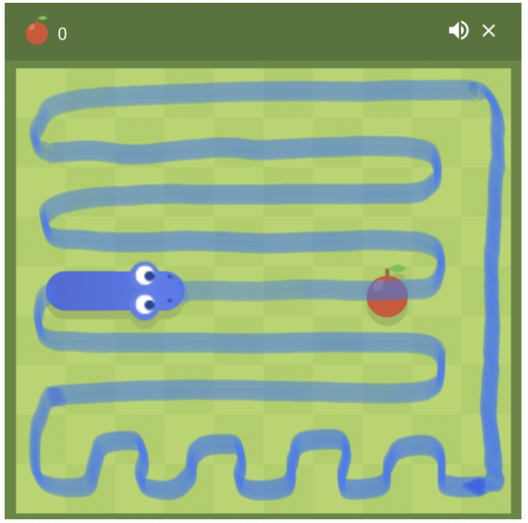*Figure 3 – A Hamiltonian cycle passing through all points of the board. Image by Author based on screenshot of Google Snake (Fair Use).*

As noted in the previous lesson (1.2.1 Game Engagement), adding options to a video game can prevent it from becoming monotonous. It can also add challenge and challenge the player's ability to handle the multiple options in the game. For those game participants, my version of the snake game adds a certain number of options that were not available in previous versions. Therefore, each added option is a new version for them and takes time to learn. So my next step in the direction was to determine the number of options and the directional layout in the game through research.

### 1.2.3 Range of Options

The purpose of this experiment was to investigate the effect of the number of options on human engagement in a game. Based on my preliminary research on game engagement, one of my expectations of the results of the experiment was that user engagement would increase as the number of options increased, but would decrease if there were too many options. In order to find the optimum number of options, I needed to set a range of options to find how many options would start to reduce engagement, but obviously too many options would not be appropriate for a snake game, as the keyboard has a limited number of keys and too many keys would make it difficult to control the game.

The keys commonly used to play games on a computer are "W", "A", "S", "D", and keys near and keys close to these keys. [13] In general computer games, especially those that require directional control, these four keys are generally used to control direction, corresponding to up, down, left and right. So I found four other keys around these four keys, "Q", "E", "Z" and "X "This makes a total of 8 buttons, which is already a relatively large number for the player and too many for the user to operate the game. I therefore chose to use 8 as the maximum value for the number of options in the experiment, and the minimum margin of choice people can make is 2. So the range of options in the game is between 2 and 8, and the experimental environment will be built according to this range of number of options.

Based on the number of these directional keys and their placement on the keyboard, I drew a conceptual diagram (Figure 4) in an attempt to vary the snake game by setting up an experimental control group with a range of different numbers of options to explore the extent to which the number of options affects engagement. Whereas setting the direction as shown in the diagram visually better matches my preconceptions of the snake's direction of travel, it also goes some way to preventing players from breaking the game by following the Hamiltonian route [11] as used by Thomas Hikaru Clark (Figure 2), as the path of the snake's movement is no longer traceable each round.

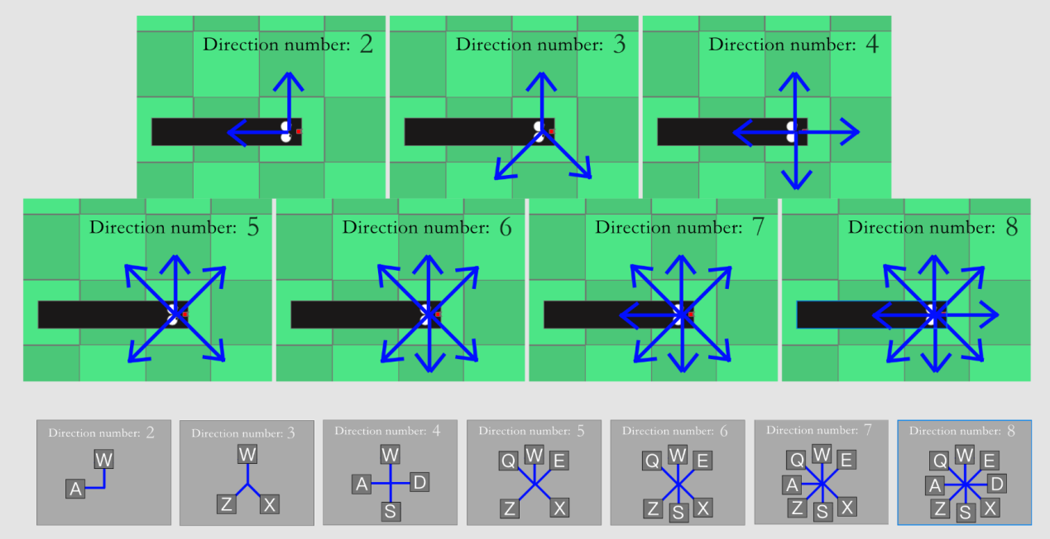

*Figure 4 – Ideal snake heading direction in each round*

### 1.2.4 Unity

This project is based on adapting an existing snake game to explore the relationship between the options in the game and the player's engagement, so I chose Unity [14], based on C# as the main programming language and using today's IDEs as the development software for my snake game inspired game. With analysis and testing tools to find problems and optimise the code, Unity is an efficient game design and programming tool for game programmers, with a huge amount of quality code and development resources, which was a relatively good choice for me as I needed to create a game body in a short period of time and needed to debug it repeatedly.

### 1.2.5 Data Collection and Analysis

# During the data collection phase of the experiment, I looked for ways to upload data remotely, including sending data to my http server via Unity's WWWForm, which works by generating form data via unity's own WWW class to publish to a web server [15], but found it less efficient, so I found a more convenient and efficient way to Using WWWForm to generate user feedback in-game online by filling in the Google form response code and generating a Google form, and then importing the Google form into Microsoft excel for analysis, this is discussed in detail in 4.3Uploading and recording data.

# 2.Professional Considerations

The project will conduct user testing on adults. In the following section, the professional considerations of this project will be discussed.

### 2.1 BCS CODE OF CONDUCT

This Code of Conduct:

• sets out the professional standards required by BCS as a condition of

membership.

• applies to all members, irrespective of their membership grade, the role they fulfil,

or the jurisdiction where they are employed or discharge their contractual obligations.

• governs the conduct of the individual, not the nature of the business or ethics of

any Relevant Authority*

### 2.1.1 Public Interest

I shall...

a) *“Have due regard for public health, privacy, security and wellbeing of others and the environment.”*

The experiment will not include any intrusive questions, respecting participants’ privacy.

b) *“Have due regard for the legitimate rights of Third Parties*.”*

I will not be releasing the created Snake-inspired game to the public and so it will not infringe Snake’ copyright laws.

c) *“Conduct your professional activities without discrimination on the grounds of sex, sexual orientation, marital status, nationality, colour, race, ethnic origin, religion, age or disability, or of any other condition or requirement.”*

Experiment participants will be chosen based on availability. No discrimination will take place during the selection process.

d) *“Promote equal access to the benefits of IT and seek to promote the inclusion of all sectors in society wherever opportunities arise.”*

A device to take part in the experiment will be temporarily provided when possible to participants that do not have their own.

### 2.1.2. Professional Competence and Integrity

I shall…

c) *“Develop your professional knowledge, skills and competence on a continuing basis, maintaining awareness of technological developments, procedures, and standards that are relevant to your field.”*

During the development of the experiment environment, my knowledge in the area will grow. This will always be considered and applied.

e) *“Respect and value alternative viewpoints and, seek, accept and offer honest criticisms of work.”*

*Feedback will be sought from* my *supervisors and peers throughout and taken into account.*

g) *“Reject and will not make any offer of bribery or unethical inducement.”*

No participants of the experiment will be bribed to take part.

### 2.2 Ethical Review

Due to the fact that this project requires feedback from humans, ethical considerations are required. The following ethical review does not represent the final version and is for reference only. I will discuss this with my supervisor in the future.

1. Participants were not exposed to any risks greater than those encountered in their normal working life.

*This project is a non-violent video game, there is no significant risk.*

This project is a non-violent video game, there is no significant risk.

1. The study materials were paper-based, or comprised software running on standard hardware.

*Participants will play games on my personal laptop and fill out any feedback form on my personal laptop.*

1. All participants explicitly stated that they agreed to take part, and that their data could be used in the project.

*Before the user test starts, I will introduce the project profile to the participants, what they are asked to do, and what information is collected and stored.*

1. No incentives were offered to the participants.

*Participants participate voluntarily, without any rewards and feedback on specific emotions.*

1. No information about the evaluation or materials was intentionally withheld from the participants.

*As a video game, the nature of the project means that participants will find some problems and information in the game. It is important to observe how the user interacts with the game under some hidden conditions, so in this sense, some information is not fully told to the user. However, participants will know that they are being observed, have a brief understanding of the project goals, and have the opportunity to ask questions before and after the test.*

1. No participant was under the age of 18.

*Participants will be university students so they are all over 18 years old.*

1. No participant had a disability or impairment that may have limited their understanding or communication or capacity to consent.

*Participants will be undergraduates of the university (with the cognitive ability of university-level courses), and user tests will be held on campus (without lack of sleep or inability to properly agree).*

1. Neither I nor my supervisor are in a position of authority or influence over any of the participants.

*Participants will be my schoolmates, and my supervisor is in an authoritative position as part of the teacher, and the identity of the participant will be unknown, except for myself.*

1. All participants were informed that they could withdraw at any time.

*The ability to withdraw in time will be described in the abstract.*

1. All participants have been informed of my contact details, and the contact details of my supervisor.

*During the briefing and debriefing period, participants will be provided with notes containing my and my supervisor’s e-mail addresses.*

1. The evaluation was described in detail with all of the participants at the beginning of the session, and participants were fully debriefed at the end of the session. All participants were given the opportunity to ask questions at both the beginning and end of the session.

*A briefing and debriefing scripts containing these contents will be used to perform all user tests*

1. All the data collected from the participants is stored securely, and in an anonymous form.

*All questionnaire information, feedback forms and observation notes will be stored securely on my personal password-protected laptop, and any identifiable information will be edited.*

# 3. Program Objectives

### 3.1 Project Aims and Objectives

The overall aim of this project is to design, implement and evaluate a variant version of the snake game (discussed in section 1.1) to find the relationship between people's participation in the game and the number of game options. The evaluation method will be tested remotely with at least 20 people through a link to the experiment's website. The project will use the Unity game engine to run on all computers with a network connection.

### 3.1.1 Primary Objectives

The primary objectives of this project are:

* Use existing programming tools to build a different version of the snake game that supports changing the quantity of the forward direction.
* Interview at least 3 users through a zoom meeting, in-depth discussion of the game experience, opinions and suggestions.
* Improve game details, making the game environment closer to the experimental purpose.
* Developed a scoring system to jump out every minute, allowing users to rate the level of engagement.
* Invite 20 people to participant in this study, and tested remotely through a link to the experiment's website.
* Automatic uploading of game data and user feedback from the game to Google form for data analysis.
* Use excel's data analysis tools to analyse the data collected.
* The collected user engagement ratings, the scores of each game, the error rate, and user feedback are combined and analysed, and the analysed results are presented as two-dimensional linear images.

### 3.1.2 Extensions

The possible extensions of this project include:

* Analyse how the number of options affects engagement by combining the game score with the user error rate in the game
* A simple questionnaire was administered to users during user testing, which included age, gender, rating of game play and how they felt after playing the game.
* Explore the effect of user age on engagement scores
* Explore the impact of how often users play snake games in a year on engagement scores

### 3.2 Requirements

This section describes the functional requirements of the game and the functional requirements of the experimental environment as well as the domain requirements.

### 3.2.1 Snake-inspired Game Requirements

### *3.2.1.1 Functional Requirements*

The game shall…

* have a board with a height of 20 and a width of 20
* have 7 rounds, each round has a different number of directions to move the snake forward(from 2 to 8)
* calculate and show the player their score in the game
* have a random points display on the screen, when the snake eats a point, the next point is randomly generated
* have a snake with an initial length of 1, the length of the snake increases by 1 every time a point is eaten
* display the number of direction options for each round
* end when the snake hits the wall or itself
* end when the length of the snake reaches its maximum
* have the ability to be paused at any time
* have options to restart or quit the game

The player shall…

* have the ability to:
  + - * + Use their keyboard to switch the direction of the snake

### *3.2.1.2 Domain Requirements*

The game shall...

* have a similar look to Snake
* have a wide range of abilities can understand it

### 3.2.2 The experiment Requirements

### *3.2.2.1 Functional Requirements*

The experiment shall...

* show instructions on how to perform the experiment and the game
* show the player a questionnaire at the start of the experiment
* show the player a questionnaire after each level
* show the player a questionnaire at the end of the experiment
* have a record of the results of the questionnaires
* show players each of the five rounds of the game in sequence
* be possible to store statistics about participants in the game

***3.2.2.2 Non-Functional Requirements***

The experiment shall...

* allow users to participate simultaneously on one device
* allow multiple devices to participate in the experiment at the same time
* written in Java and integrated into Unity
* have real-time feedback data

### *3.2.2.3 Domain Requirements*

The experiments shall be simple to perform and easy to understand.

### 3.3 Preliminary design

This session describes my initial design for the game.

### 3.3.1 Directional options

I started by designing the directional instructions for each round of the snake game mentioned in 3.2.1 and designed 7 different placement styles corresponding to the 7 options. This directional indication can be used as a reference for the player during the game. As mentioned in 1.2.3, the choice and placement of the keys should ideally fit the default keys used by the player to operate the game, and I decided to design the directions for each round to look like the ones in Figure 5.

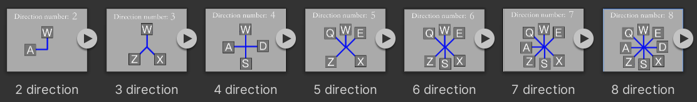

*Figure 5 – Direction design*

Then I noticed a problem, in a round with only 2 directions, if the snake can only go in two fixed directions, then the snake will soon hit the wall and die, which is unavoidable. So I decided to change the rules of the snake game so that instead of dying when it hit a wall, it would go through it and out through the wall opposite that wall, as shown in Figure 6. As this project is an attempt to identify generic theories in the game and is not an experiment for the snake game, a small degree of adaptation of the snake game is in line with the design objectives.

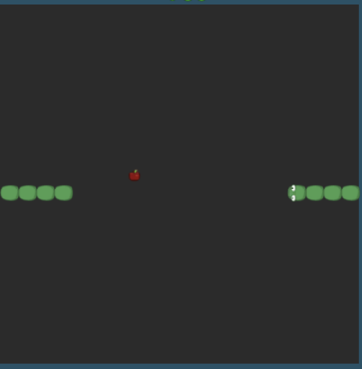

*Figure 6 – Snake go through the wall*

### 3.3.2 Game flow

To show my design process more visually, I drew a flowchart to show the flow of the game. Figure 7 illustrates this process. The blue part is the main screen of the game, the yellow part is the pop-up window of the game and the purple part is the functional module of the game, which is used to make decisions about the switching of scenes in the game. The arrows depict how each section is triggered in relation to each other. These correspond to the scenes in the experiment.

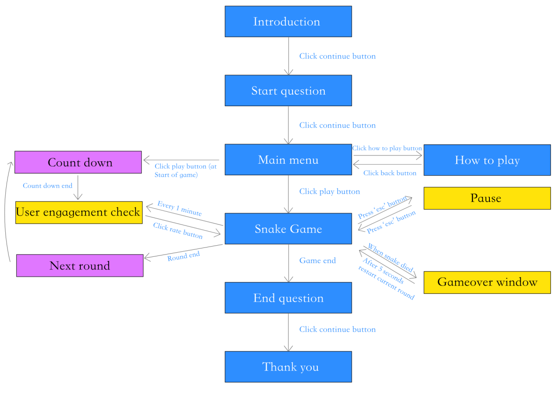

*Figure 7 – Game Process Flow Chart*

The main game scene will consist of a snake game screen, directional indicator pictures and a time display. The directional indicator pictures are designed to give the player a clear view of the number of directions for the current round and the corresponding buttons for the different directions, and are represented in Figure 8. All other scenes consist of backgrounds, text and buttons for the player to manipulate. The snake game with the snake body, the food and the directional indicator picture use the texture shown in Figure 9. The directional indicator can show the directions and the corresponding buttons that the user can control in each round of the game.

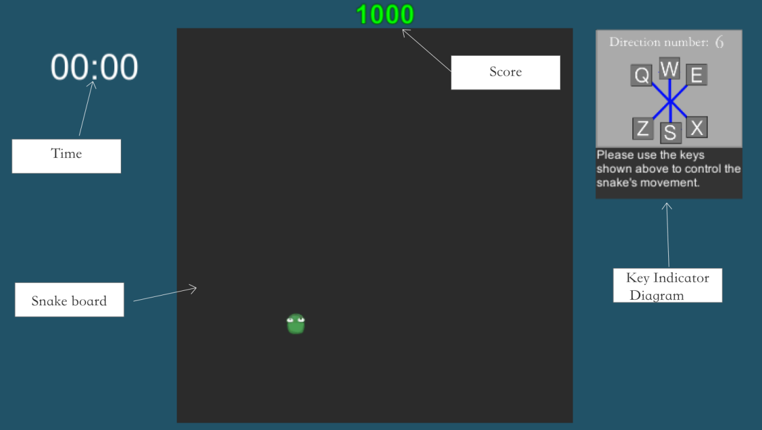

*Figure 8 – main game scene*

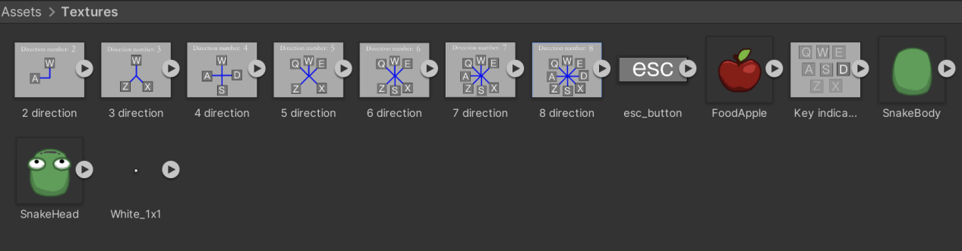

*Figure 9 – textures*

### 3.3.3 Class Diagram

I used SmartDraw to create a class diagram to show the methods of each Unity script. (shown in Figure 10). This can be used in the [4.Implementation](#_4 Implementation) to explain the approach I used when creating the C# script for the snake game inspired game.

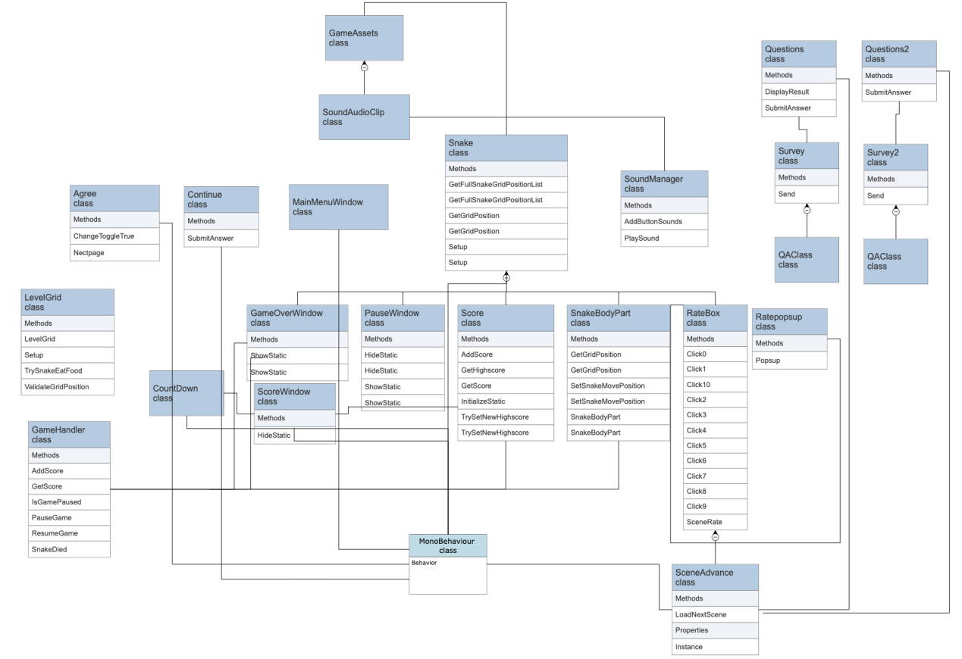

*Figure 10 – UML class diagram*

# 

# 4. Implementation

This section will describe some of the code I wrote to build an adapted version of the snake game and the process of designing the game interface in Unity. The code is implemented in C# and the Unity version is 2021.2.16. The completion of the experimental environment will be useful for informal user testing sessions where users will test the initial snake game and return data for data analysis.

### 4.1Snake Game

The core of building the experimental environment is the official snake game, so my first step was to implement the code for the snake game to be built and a working experimental environment. For the code of the snake game, I referenced a YouTube video on the basic build of the snake game [16] and adapted it to my needs for the experiment.

Figure 11 shows a png image of the open-source snake head, snake body, a 1*1 white square and food apple that I downloaded from the website. The background of the game will be made up of small 20*20 squares, where the 1*1 white square will be changed by changing its colour in Unity to make up the snake background. The head and body of the snake and the apple are the same size as the 1*1 squares.

The snake consists of a snake head and a snake body. every time the snake eats an apple, the number of snake bodies behind the head is increased by 1. the apples will appear in random locations in the background of the game using a random function.



*Figure 11 – textures*

### 4.1.1Snake Movement

In the snake game, the snake automatically moves along the grid in one direction at the start of the game. I created a class Awake() where the snake will start moving from a specified position when the game starts. First it needs to know where it is at the moment, and since this game is 2D I need to store the x and y position of the snake. Here I use *gridPosition* to store the position, and I set the starting position of the snake at (10, 10) which is the middle of the page. Then the snake's position has to be moved in the grid within a certain amount of time. I created a variable *gridMoveTimer* to calculate the time, defining the time it takes until the next move as 1 second. I also created a default move direction which is to the right, so that the snake would move to the right by default at the start of the game.

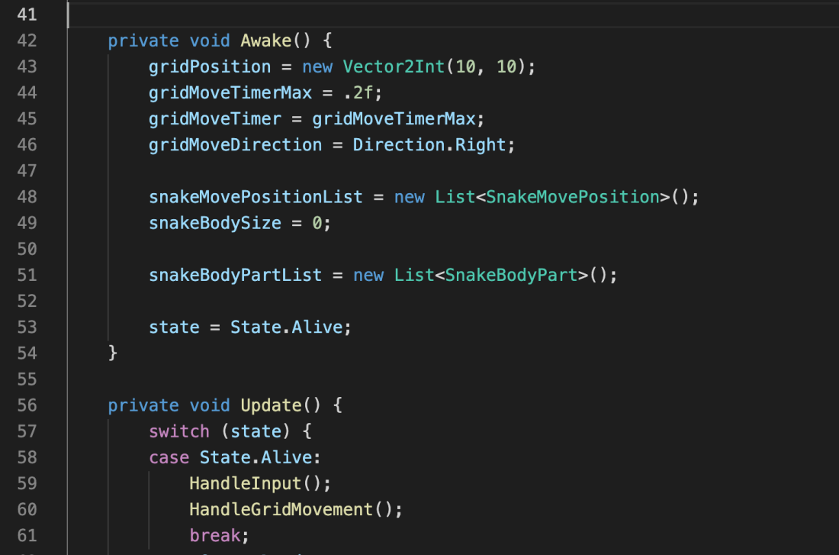

*Figure 12 – Snake Movement_1*

In order to make the snake change direction according to the keys we type, I use HandleGridMovement to define “W”, “S”, “A” and “D” on the keyboard to control the up, down, left and right of the snake respectively. When “W” is pressed, the direction of the snake's movement will only change to up if the snake's current position is not down.

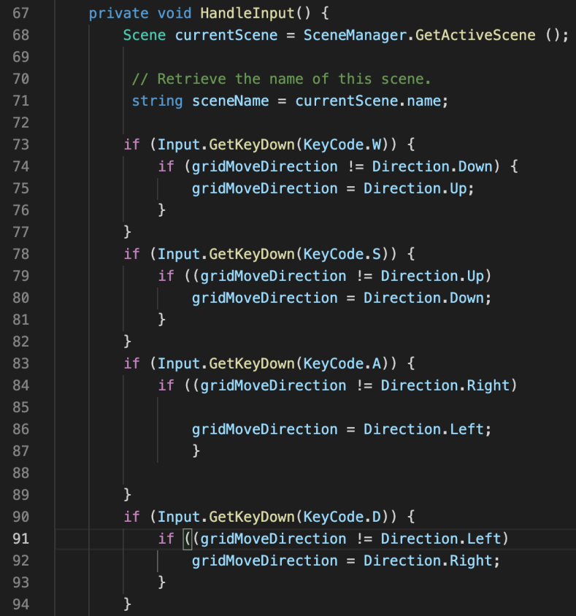

*Figure 13 – Snake Movement_2*

### 4.1.2 Snake ate Food

In the game the snake's food is randomly generated anywhere on the board whenever the snake eats the last food. So I created a class LevelGrid() to generate random food on the grid, *foodGridPosition* stores the random position of the food generated, and here I used a random function to generate random numbers between 0 and 9 on the x and y axes respectively to achieve this. The sprite is then connected to the game object so that the apple mapping appears randomly in the background panel.

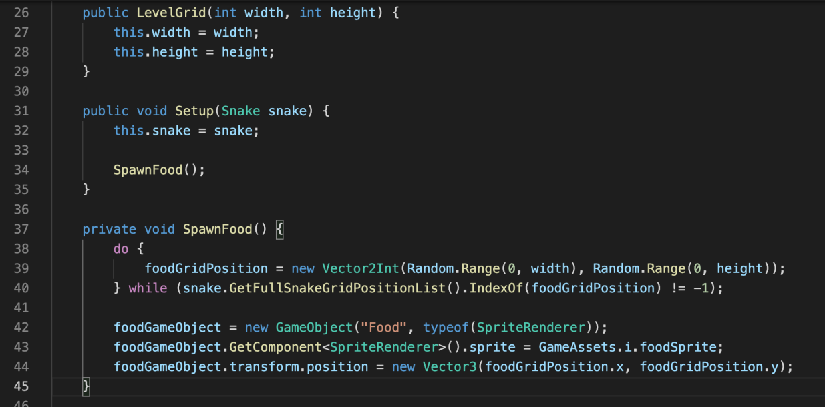

*Figure 14 – Food generate*

The next step is to implement that when the snake is located on the same grid as the apple, the apple object is destroyed and another apple is generated using a random function. I used to instantiate the object and then pass in a reference, then I created a GameHandler class to bring in both the snake and the LevelGrid, and I set up a simple set (Public void) function to pass the LevelGrid to the snake, so that all the objects had the references they needed.

After completing the reference to the game object, a simple ‘if’ statement is used to complete the snake eating the food and then the food reappearing at random and the length of the snake being added by 1.

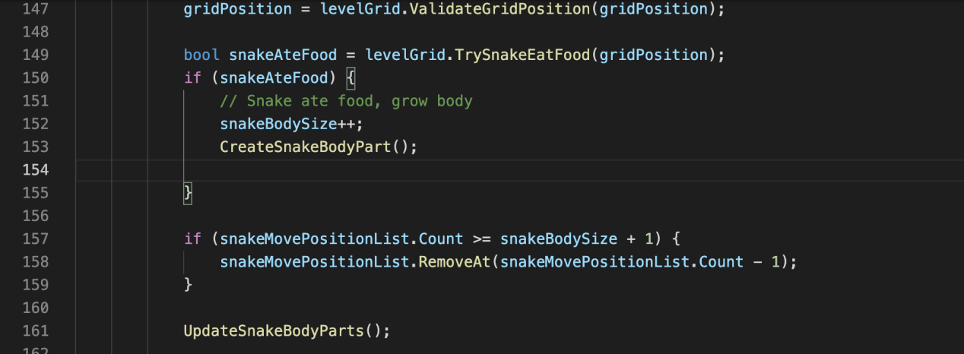

*Figure 15 – Snake grow*

### 4.1.3 Game Over

In the official snake game, the game ends when the snake bites itself or hits a wall, but based on consideration of environmental variables for later experiments, it was mentioned in 3.3.1 to make a small change to the rules so that when the snake hits a wall, the snake goes through the wall on the other side instead of dying.

I use *gridPosition* to store the position of the snake's head and *gridsnakeBodyPosition* to store the position of the snake's body. I also create a *snakeBodyPartList* to store the position of the snake's body. I use an ‘if’ statement to determine if the list of coordinates of the snake's body has the same coordinates as the current position of the snake's head, and the game ends if the x and y coordinates of the body and the position of the snake's head are the same.

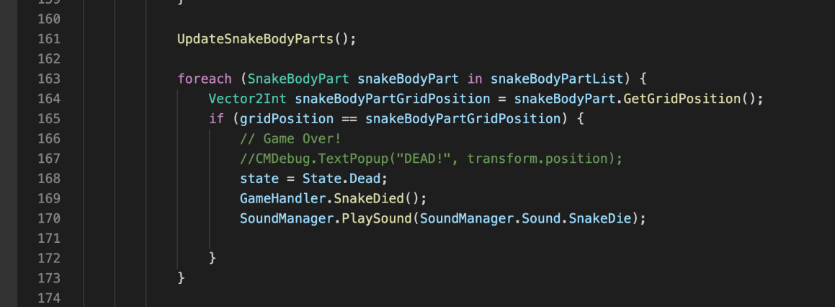

*Figure 16 – Snake die*

To enable the snake to walk through the wall, I use *ValidateGridPosition* to check the snake's position. When the snake's position on the x-axis is less than 0, the snake's position is updated to the background width-1 position, which is the far right of the background panel, and the same on the y-axis.

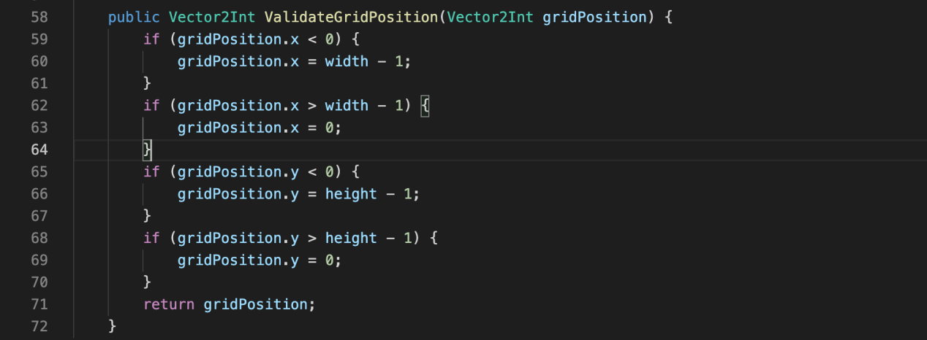

*Figure 17– Go through the wall*

### 4.1.4 Multiple Direction

Once the basic snake game is built, I added the experimental variables, which is add 7 game rounds corresponding to 2 to 8 game options.

I added four directions to the source code, which are top left, top right, bottom left and bottom right. As shown in figure 18, I added a few lines of code to the top, bottom, left and right to allow control of the snake's direction by different keys. At this point the maximum number of options in the game reaches 8 and the minimum number of options is 2. By setting up 7 more different game scenarios, each corresponding to one of the 2 to 8 number of options, the game has the ability to control the independent variables.

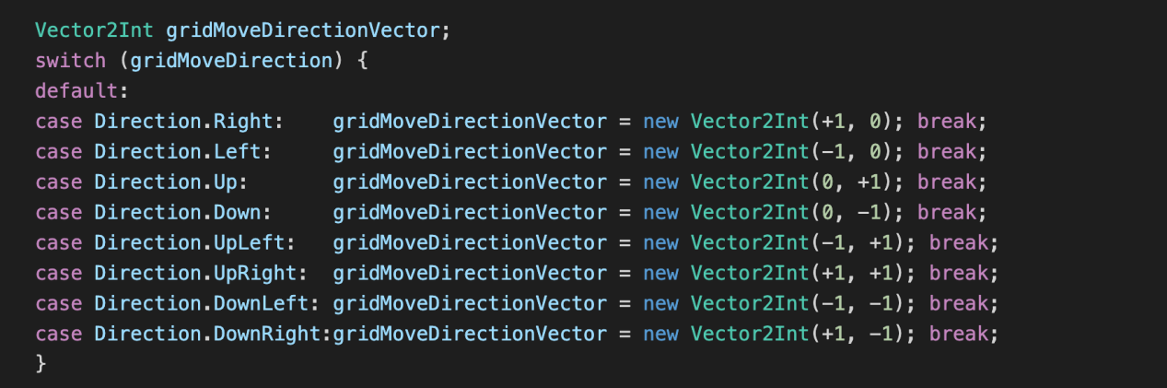

*Figure 18 – Direction Code*

In order to set the number of options corresponding to different rounds, I use several ‘If’ statements to check the current scenario the user is in, as shown in Figure 19. Where “2D”, “3D,” “4D” etc. indicate the name of the scene and the number indicates the number of options in the round. When the user presses the direction responsible for controlling the direction the snake is pointing, a determination is made as to whether the direction is allowed for the round they are currently in. This means that the user can only press the few direction keys that match the current round, otherwise the head of the snake will not respond.

For example, when in a round with three options, the user can only press a specific three direction keys, W, Z, X. The direction in which the arrow keys point is shown in figure 5 in 3.3.1Directional options.

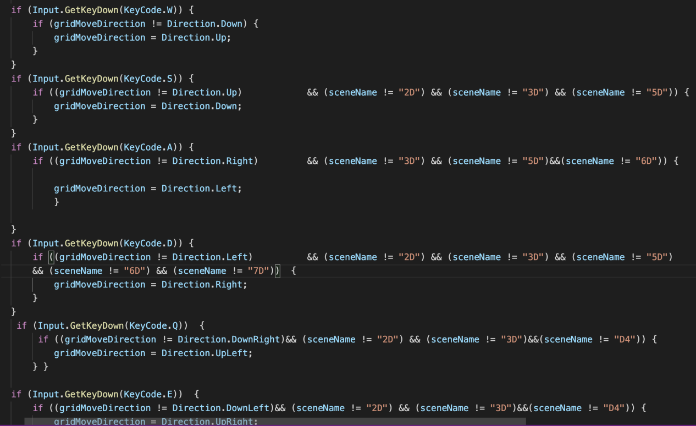

*Figure 19 – Direction Keys*

### 4.1.5 Usability User Testing

### As I mentioned in 3.1.1 Primary Objectives, after I had completed the code part of the main game, I used user-centered usability testing to avoid potential problems with the game and ensure that it would run smoothly. A total of three volunteers participated in this test and their feedback and the changes I made to the game can be seen in Appendix B.

### 4.2 Experimental interaction screens

In order to give the participants an idea of what the experiment was about and how the process was implemented, I decided to make some pages to explain the experiment and a few simple questionnaires to collect basic information. These pages are explained below and the game flow is explained in 3.3.2: Game Flow.

To make the game more intuitive for the players and to make the experiment more professional, I decided to keep these pages simple.

### 4.2.1 Introduction and Declaration

Upon entering the game, the user will be presented with the introduction and declaration pages, as shown in Figure 20. This page is meant to tell the user what to expect in the experiment and how long it will take to complete. Participation in the experiment should be voluntary, the user should have the right to refuse to take part in the experiment and if they lack patience or do not wish to continue during the experiment they can withdraw from the experiment at any time.

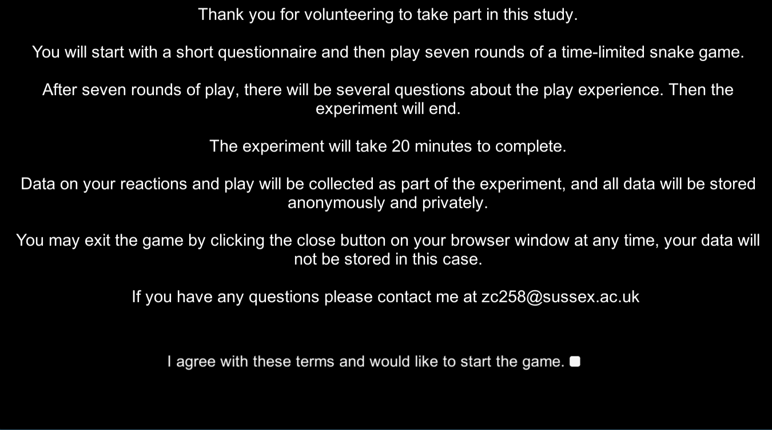

*Figure 20 – Introduction screen*

I declare to users that I will not collect their private information; their data will be stored securely and anonymously on my personal computer. This is also in accordance with the ethical guidelines in [2.2 Ethical Review](#_2.2 Ethical Review). When clicking on the toggle button in Figure 20 to agree to the above terms, this means that they agree to this disclaimer. The Continue button will then appear, as shown in Figure 21. This button will lead the user to the questionnaire screen.

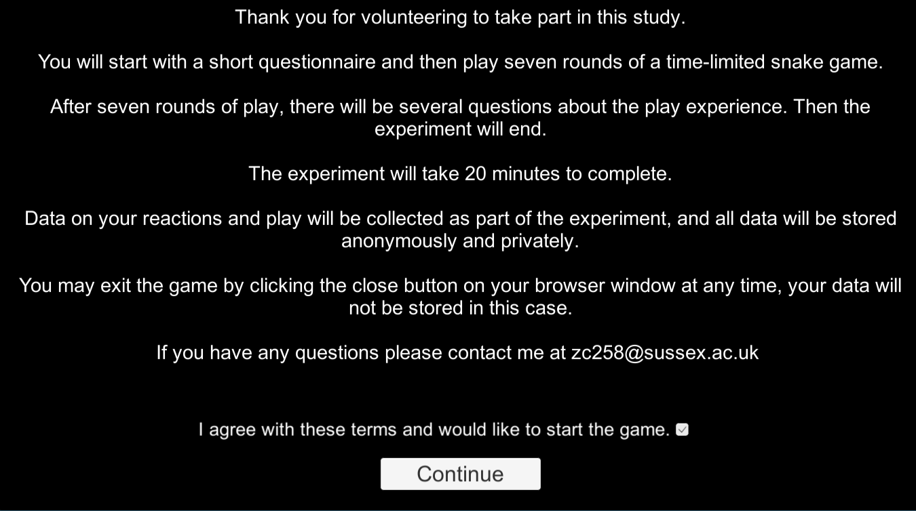

*Figure 21 – Introduction screen-2*

### 4.2.2 Questionnaire Screen

In the questionnaire screen, the user is asked to do a few short multiple choice questions (Figure 22). The purpose of this questionnaire is to obtain basic information about the user in order to make a brief distinction between user groups at a later stage. It is also possible to explore the effect of user age on the attractiveness of the game and whether the frequency with which users play the Snake game has an impact on game engagement.

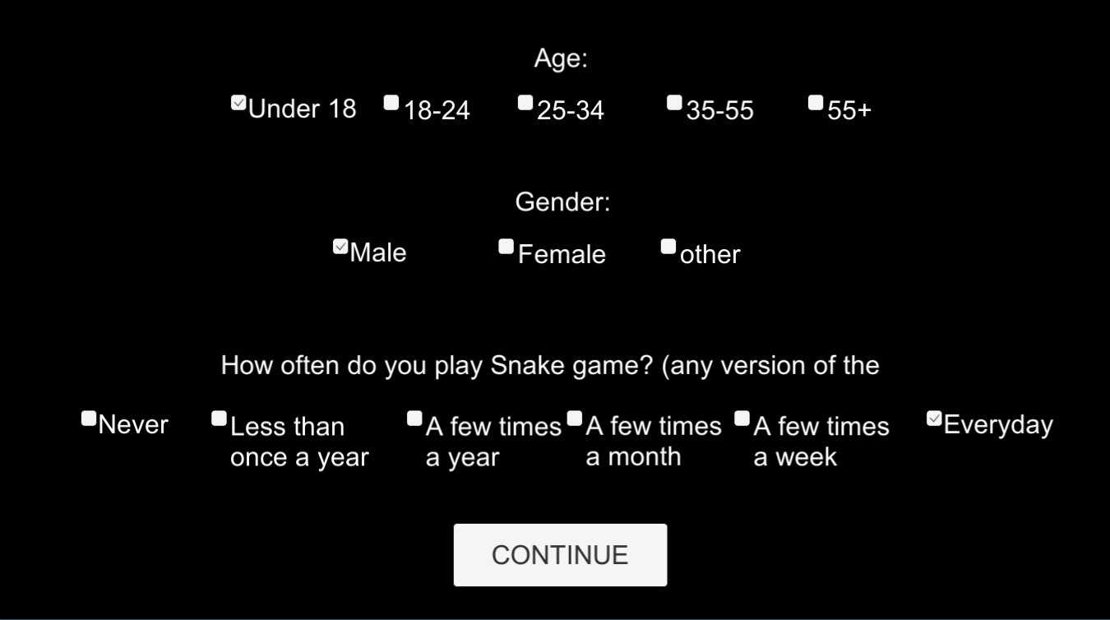

*Figure 22 – Q*uestionnaire *Screen*

### 4.2.3 Main Menu Screen

After completing the questionnaire, the user is taken to the main menu screen (Figure 23). In order to make the experimental environment more similar to the Snake game, I made the screen before the game starts similar to the main menu page of the Snake game, this is to simulate the user's experience when playing the real Snake game in order to get the most realistic results. I made three buttons: *play, how to play* and *exit.*

When the user clicks on Play it will start the game and take them to the game page, which will be explained in [4.2.4: Main Game Screen](#_4.2.4 Main Game Screen).

When the user clicks on the *how to play* button, a page with the rules of the game pops up (Figure 24). The snake image and the apple image were created using the texture downloaded from the website mentioned in [4.1: Snake Game](#_4.1Snake Game), and the directional button icons were created using Adobe XD. This page clearly shows the rules of the snake game and how to manipulate the snake. The user only needs to control the appropriate arrow keys (shown in the top right corner of the game page) to make the snake eat the apple to score points.

If the user wants to leave the experiment immediately, they can click on the *exit* button and their questionnaire information will not be collected at this point.

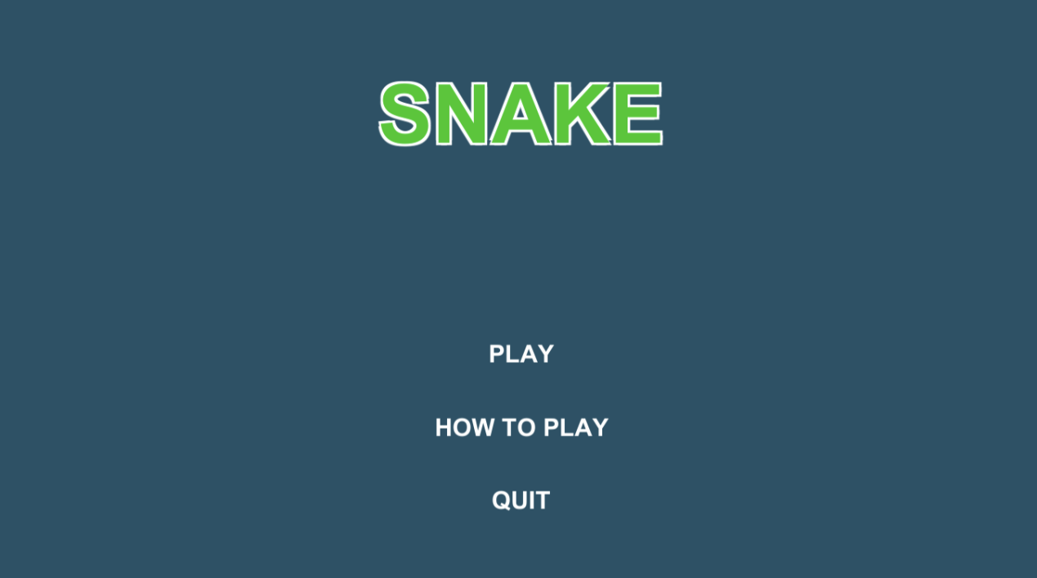

*Figure 23 – Main Menu Screen*

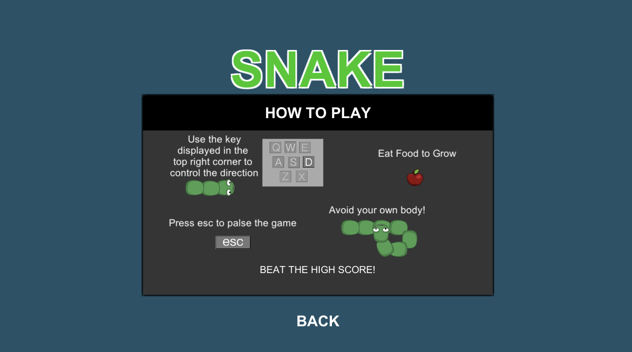

*Figure 24 – How To Play Screen*

### 4.2.4 Main Game Screen

When the user clicks the play button, they enter the Experiment - Snake game inspired game.Figure 25 shows the main game screen, currently displaying a round of 2 options, with the snake having 2 directions to move in. The game has seven rounds in total, each corresponding to a different number of options (2-8). The moment the user presses the play button, a random function generates a random scene number from a list representing the 7 scene numbers, then Unity's SceneManager reads this scene number and jumps to the corresponding round, the scene number is then removed from the list, and every time the user completes a round, it randomly jumps to the next round via the random function. So that the number of options in each round is randomised, rather than in ascending order. This is to more accurately capture user feedback on engagement with the game, which could be repetitive and boring if sorted in order from smallsest to largest.

At the start of the game, the HameHandler class defines the life and death status of the snake, adding 1 to the death count every time the snake's head touches the snake's body. UnityEngine's GetActiveScene() is used to detect the currently running scene, adding 100 to the score every time the snake eats an apple, and Getscore.Tostring is used to read the current round's Tostring is used to read the final score of the current round.

Playpref is used to store parameters for each scene: how many times the snake has died, the player's score, the current scene number, the player's satisfaction with the current scene (captured using the engagement check in Figure 26), and the number of steps the snake has moved. When the whole game is finished, playpref sends all the game parameters to the Google Form website for aggregation (explained in 4.3 Uploading and recording data.).

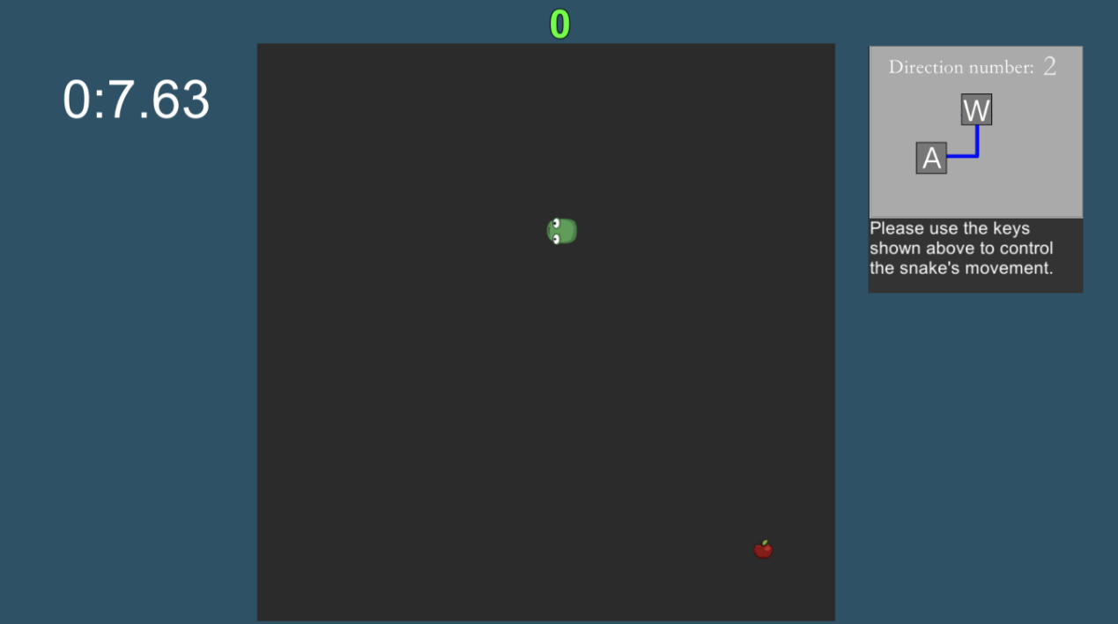

*Figure 25 – Main Game Screen*

The design of the interface (Figure 24) is similar to that of the Snake game, except that I have added a time display and directional button guidance. The time display increases from 0 seconds instead of counting down, because I think it tends to be overwhelming and makes the user pay more attention to the remaining time than to the game itself. The directional button indication allows users who are unfamiliar with Snake to get up to speed quickly. I have used black as the background colour for the snake activity area so that the snake and apple can be highlighted more and have a high contrast. For the main background I have used bluish green, as this colour is more comfortable for the human eye.

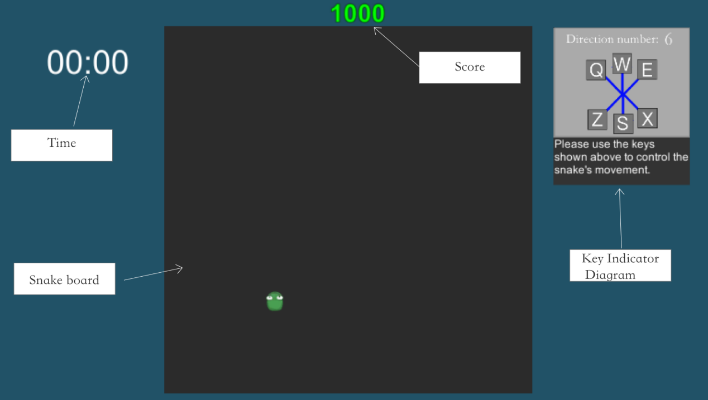

*Figure 26 – Main Game Screen Illustrations*

An engagement check pops up every minute of the game (Figure 25), a two-minute round, and each round the user scores the engagement twice in order to explore the impact of the time the user plays on the engagement of the game. The buttons are designed to be identical white squares without displaying the value they represent to avoid users subconsciously scoring repeated engagement scores, with the squares representing scores from 0 to 10 from left to right, and each time the user presses a square, the pop-up disappears and play continues. In the C# class for engagement check there is a count value, when the value equals 2 the random function mentioned earlier in this section is enabled and the game randomly moves on to the next round.

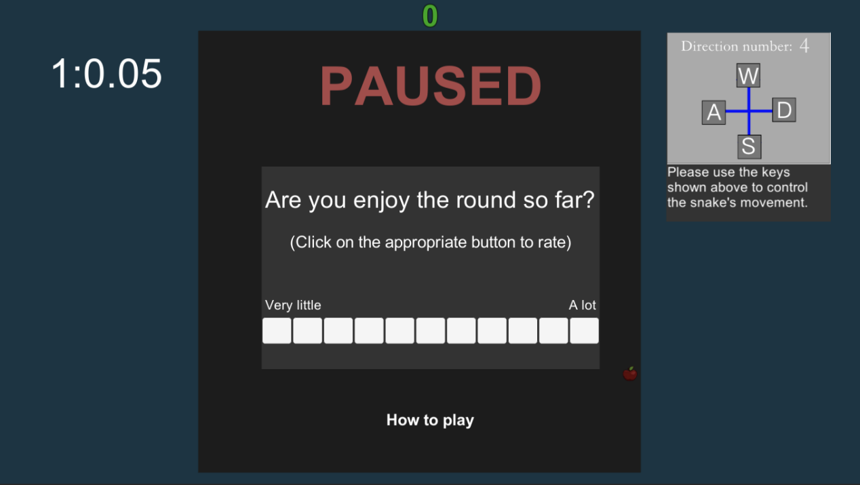

*Figure 27 – Main Game Screen Engagement Check*

The user can pause the game at any time during the game by pressing *esc* on the keyboard. When the *esc* key is pressed, a pause window pops up with two buttons: resume and how to play. Pressing *resume* button will resume the game, or they can press *esc* again to resume the game. Pressing the *How to play* button will take them to the game rules screen shown in Figure 23 of Section 4.2.3:Main Menu Screen to allow the user to review how to play the game.

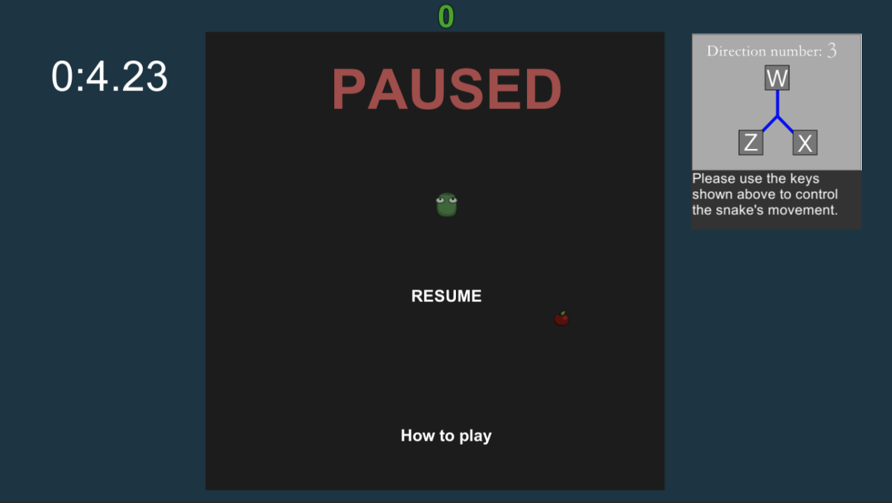

*Figure 28 – Main Game Pause Screen*

Every time the snake dies (the head touches the body), a countdown window pops up (Figure 27) and after 5 seconds the round starts again. However, feedback from the user testing phase (shown in Appendix B) suggested that restarting after each death would significantly increase the play time and make users impatient. So I fixed this problem before the formal start of the experiment, so that if a user died within 1 minute of the round, the round would restart, and if they died in the second minute of the round, they would only have to play for another minute until they completed a second engagement check. The reason for not allowing the user to regain the length and state of the snake before it dies is that it doesn't fit in with the official snake game (which restarts every time the snake dies) and I was concerned that it would detract from the game experience.

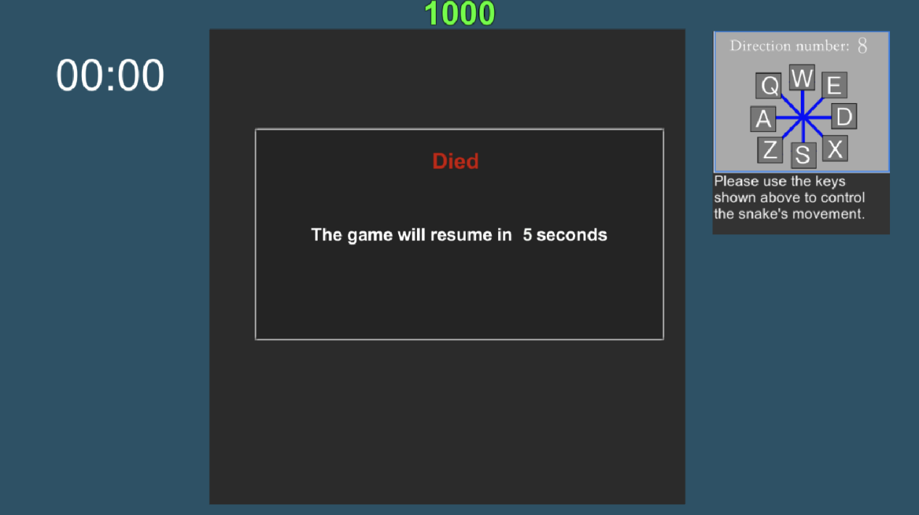

*Figure 29 – Main Game Died Screen*

### 4.2.5 End Questionnaire Screen

Once the user has completed all the rounds, they will be taken to the final questionnaire page (Figure 28), which consists of two questions in which they can enter their answers (no more than 500 characters). The aim is to get a brief idea of how users feel after completing the experiment and to analyse the data in order to study the impact on participation once they have improved their skills. When the user clicks on continue, their options in the first questionnaire and their answers in this questionnaire are converted into strings and sent to the GoogleForm website, along with the game data stored in the playpref as mentioned in 4.2.4 Main Game Screen. If the user does not press the continue button, then all data and questionnaire answers are not uploaded and are not recorded on my computer.

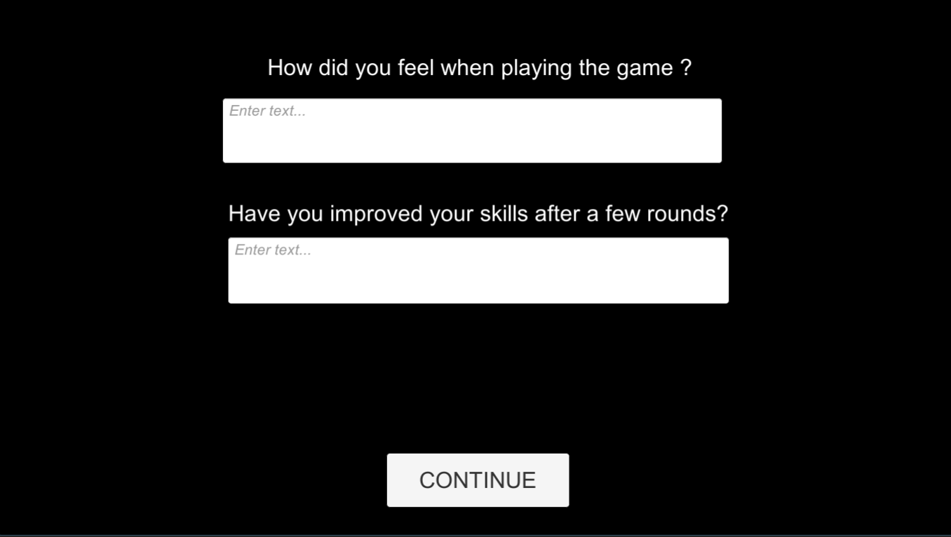

*Figure 30 – End Questionnaire Screen*

### 4.2.6 End Screen

The experiment ends with a simple page (Figure 29) telling the user that the experiment is now over, and they can click the QUIT button to leave the site.

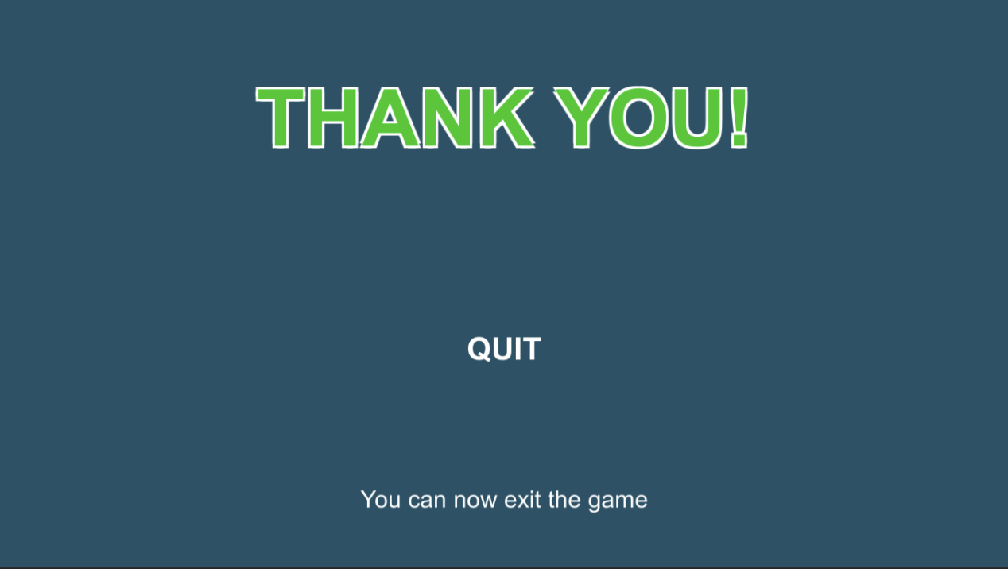

*Figure 31 – End Screen*

### 4.3 Uploading and recording data

The experiment was started by inviting users online via a link I sent them to the Unity Webgl platform, so I needed a way to send the data generated during the experiment online to my computer. I initially tried using Unity's WWWform to send the data to the http server, but this didn't work well as the data sent to the server was too large and cluttered for me to collate and analyse later. So, I posted the data from the form I had designed to a Google Forms response spreadsheet. I used Google Forms to create several questions that corresponded to the user's information and game data. The Send() class used to send the data in the code updated the URL link of the google form to the form share link I had created, imported the input code to the response code corresponding to each piece of data, and successfully sent the experimental data to the Google form created by V through the AddField function of WWWForm. This code can be seen in the class in Survey.cs.

The data collected was then presented in sheet form using the online automatic sheet generation feature of Google Forms (Figure 30). This would allow me to better analyse the data and then I converted the Google Sheet into Microsoft Excel format.

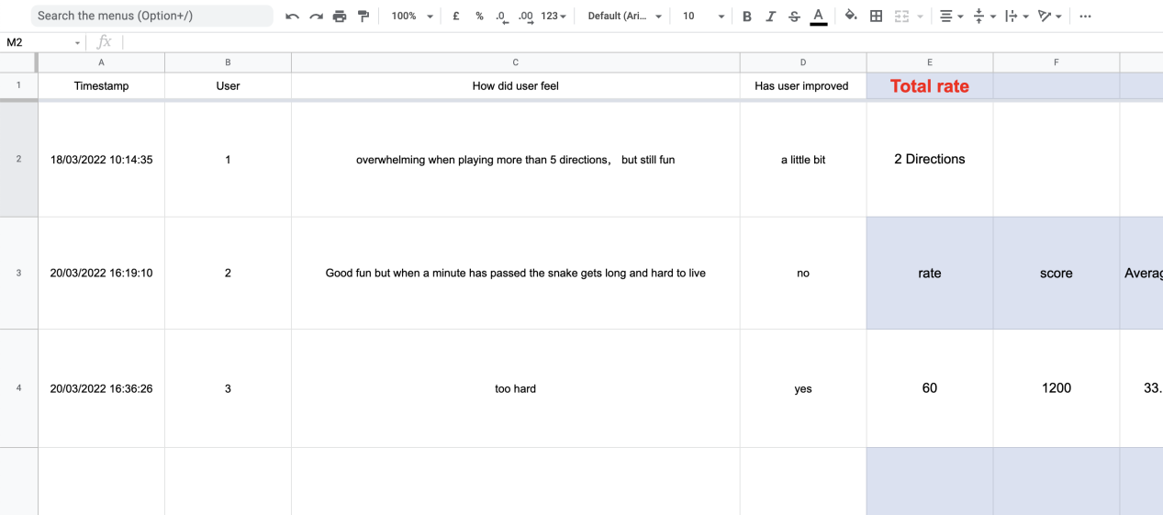

*Figure 32 – Google Form*

Figure 30 shows the two questionnaire questions answered by the user at the end of the game and part of the in-game participation check data. timestamp is the time the user took part in the experiment automatically generated by Google Sheet. the user is the primary key of the whole table and is uniquely identified in the table, it is associated with the data in the same row. This user ID allows me to combine all the data together and to identify individual data for different users when analysing the data. The other categories in the table are described below.

**Round number**

This column is used to mark the round numbers, as the order of the user's rounds in the game is random, I have numbered each of the 7 rounds to indicate the number of options for each of the 7 different numbers, this is used to differentiate between the user's completion of the game and the engagement survey in the different rounds.

**Score**

This column records the total number of points the user has accumulated by eating apples in each round (100 points per apple eaten) and is used to record how well the user has completed each round. The score is uploaded to Google Sheets as a string at the end of each round, along with the current round number.

**User rating**

The user's score for each round is recorded in this field. Every minute during the game an engagement check pops up and the user indicates their satisfaction with the game by clicking on a button with the appropriate level, from left to right, from 0 to 100, with each button representing 10 points. Each time the user clicks a button, the corresponding score and current round number is uploaded to Google Sheets.

**Total number of steps**

The snake will take 4 steps every second in the game and this column will record the number of steps the snake has taken in each round of the game. The number of steps taken by the snake in each round of the snake inspired game will be uploaded to Google Sheets at the end of the round and this will be used to calculate the average number of steps taken to eat the apples below.

**Average number of steps**

This column shows the average number of steps taken by the user to eat an apple in the game. This is obtained directly in excel using the following formula,

total steps / number of apples eaten (score/100)

The average number of steps shows how efficiently the user eats apples in the game and how well the user is playing.

**Error rate**

The error rate is calculated using the number of snake deaths per round divided by the total number of rounds. This value gives an indication of how likely the user is to make a mistake in a snake inspired game.

**Efficient movement**

The number of valid moves made by the user under each number of options is recorded in this column. In the snake game, whenever an apple appears randomly on the map, the shortest distance between the snake and the apple is calculated, this will be related to the options for each round, the options vary and the path between the snake and the apple varies. For example, if the number of options is 4, the snake is at (0, 0) and the apple is at (3, -5), then the shortest distance between the snake and the apple is 7. When the number of options is 8, the shortest distance is 4. This is shown in the diagram below (figure 31). The distance between the user and the apple is judged during each round and if the number of steps taken by the user to eat the apple is the same as the minimum distance, the number of valid moves is added to 1.

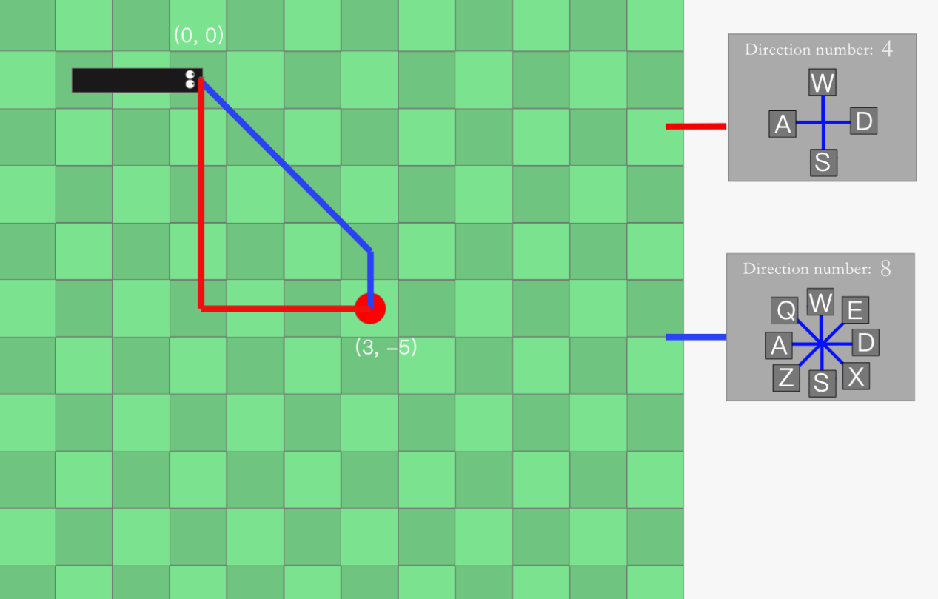

*Figure 33 –* Efficient movement

One of the most critical pieces of data is the user's score on the engagement checks that appear twice in each round, each round lasting 2 minutes, with an engagement check popping up every minute. This rating button, with a total value of 100, indicates the user's engagement level by clicking on one of the corresponding 10 buttons, with a difference of 10 points between two adjacent buttons, the leftmost being 0 and the rightmost 100. The user does not see the digitised score for each button, but rather "very little" to "a lot" instead. This gives a visual representation of how the user's engagement with the game changes as the number of options increases.

All other data will also be used to analyse whether user engagement is related to other factors in the game, which will be covered in 6.2 Key Findings is mentioned in.

# 5. Experimentation: Methodology

The experiments were built in Unity 2D, and the web-based experimental platform was built using the WebGl module that comes with Unity. I uploaded the experiments to the official WebGl platform and users accessed the website through a link shared for me and participated in the experiments remotely from their personal computers. To find participants, I contacted and invited several students from Sussex University.

Everyone was able to access the link to the experiment via the following link: [https://play.unity.com/mg/other/snake-webgl](https://play.unity.com/mg/other/snake-webgl%20)

The data upload function has now been disabled and data generated within the game will not be recorded.

# 6. Experimentation: Data Analysis and Discussion

There were 24 participants in total in the experiment the day before the analysis of the data began, after which the data collection function of the experiment was turned off. I have analysed and discussed the data based on these 24 participants' experiments, as detailed in the following sections. See Appendix F and G for details of the raw experimental data.

### 6.1 Data Analysis Methodology

All participants' experimental data was uploaded in real time to Google Sheets, which I divided into three sections, one for storing participants' engagement check in the game, one for storing participants' game data in the game, and one for storing participants' answers to the questionnaires before and after.

For the purpose of analyzing the possible causes of the change in user engagement, I combined the game data with the level of engagement. I used SQL to unite the two data tables, using the following SQL statements:

SELECT Game_data.UserID, Engagement.UserID  
FROM Game_data  
INNER JOIN Engagement ON Game_data.UserID = Engagement.UserID

The combined table can be seen in Appendix G. To find other different findings, I also combined the engagement with the number of deaths, the average number of steps and the frequency with which the user played the game to form several different new tables to facilitate my analysis of the data, which can be seen in Appendix F and G.

### 6.2 Key Findings

The focus of this experiment was to find the relationship between the user's engagement with the game and the number of options in the game, with 2 engagement checks for each round, for a total of 7 rounds. Based on the scores of the user ratings of engagement and the corresponding number of options in the game, I used Microsoft Excel to draw a graph of the combination of engagement ratings per round (Figure 32).

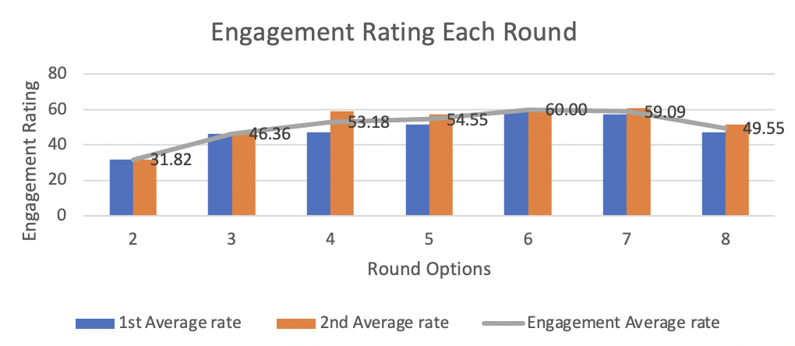

*Figure 34 – Engagement Rating Each Round*

The vertical coordinate in the graph is the average score out of 100 scored by the user on the engagement check that pops up during the game, where there are two engagement checks per round. The horizontal coordinate is the number of options, arranged from smallest to largest.

This graph depicts the curve of the user's engagement with the game as the number of options increases. We can see that as the number of options increases from 2 to 6, the user's engagement increases as the number of options increases, indicating that for a given number of options, the user's engagement is proportional to the number of options.Whereas, when the number of options reached 7, the situation changed and engagement started to drop, to 49.55 by the time the number of options reached 8.

I later found the reason for this in the questionnaire feedback given by users during the experiment (presented in Appendix B), where I found that some users reported that when they were playing the round with 8 options, there were too many directional buttons making it difficult to control. So the reason for the rise and then fall in the graph could be that users have higher engagement when there are more options, but more options are not better and when there are too many options, users find the game difficult to control and this affects engagement.

To test my suspicions, I drew another graph based on the average number of steps per round and the average engagement (Figure 33). The average number of steps is the average number of steps it takes for a user to eat an apple in a round. A higher average number of steps indicates that the user is less efficient at eating apples while manipulating the snake, i.e., the harder it is to eat apples. As can be seen in the graph, the relationship is negative correlation up to the number of 5 options, indicating that the harder it is for the user to score, the less engaged the user is. However, when the number of options exceeds 5, the relationship is again positive correlation, meaning that the user's efficiency in scoring increases, but engagement begins to decline.

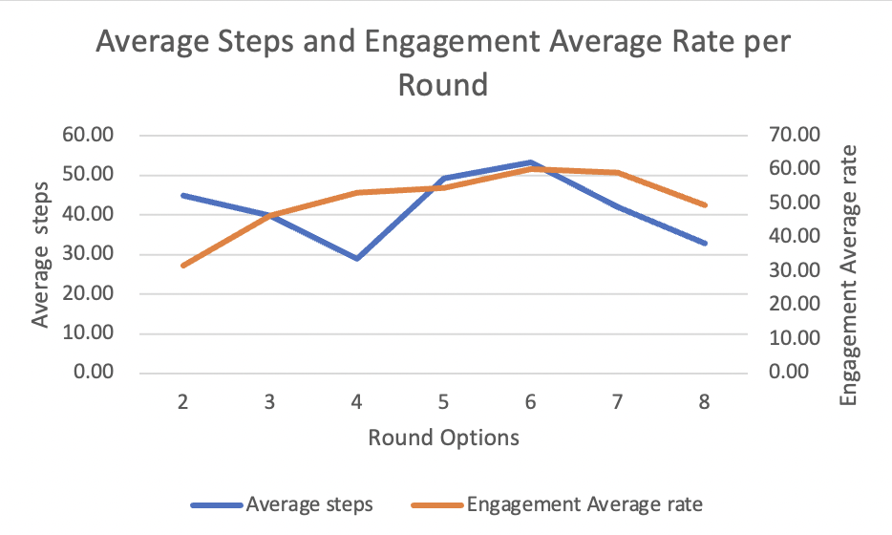

*Figure 35 – Average Steps and Engagement Rating Each Round*

However, this does correlate with the user error rate in the game, which rises significantly when the number of options reaches 7 and 8, as shown in Figure 34, which also matches the drop in engagement. When the number of options is relatively low, users' scoring efficiency matches their engagement and they are immersed in the thrill of scoring, although when the number of options reaches 6 and above, scoring efficiency is also high, but users' error rate rises significantly due to the difficulty of control, which also leads to a decline in their engagement.

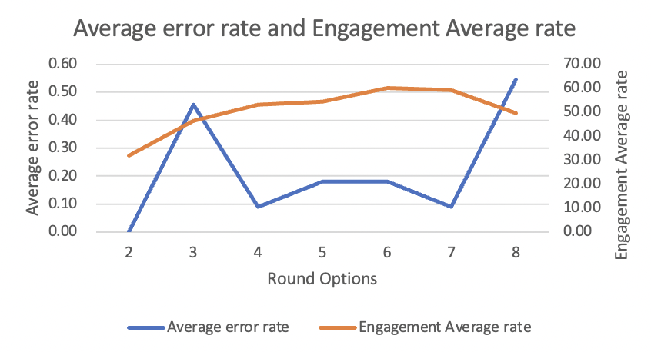

*Figure 36 – Average error rate and Engagement Rating Each Round*

This is also evident in the two separate engagement checks for each game, as shown in Figure 35, where the second score is slightly higher than the first, which may indicate that users prefer their own performance in terms of proficiency in the game. When they had a better gaming experience after the first engagement check because of the increased proficiency, they generally scored higher the second time than the first.

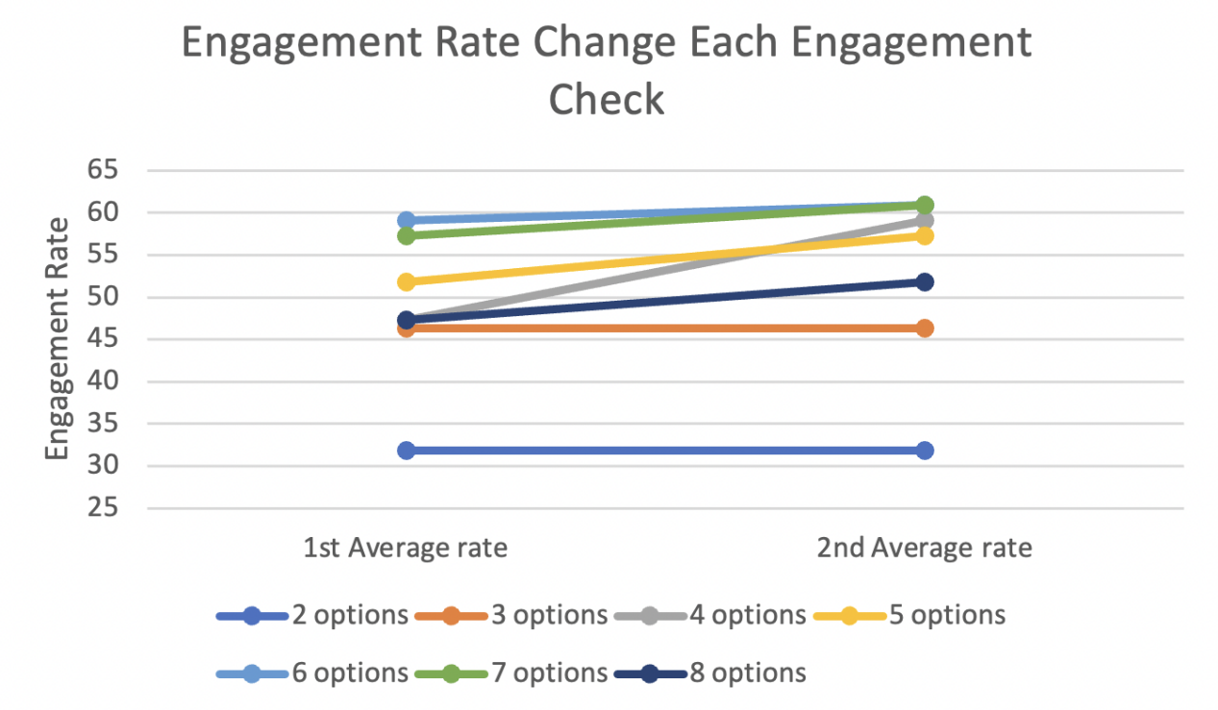

*Figure 37 – Engagement Rate Change Each Engagement Check*

In the chart we will also find that the second engagement scoring was not higher than the first for the number of options between 2 and 3. This point may be due to the fact that in the rounds with a small number of options, users may get bored and according to user feedback (Appendix F), 11 out of 24 participants found the rounds with a small number of options were too boring and this point also led to the engagement scoring in the number of options between 2 and 3 scores were not too high. The reason for users feeling bored could be related to the fact that the average number of steps it took for users to score in the rounds with 2-3 options was too high, i.e., the scoring was inefficient; users prefer the thrill of scoring and get bored when they do not get a score for a long time.

When reviewing the user's score for each round in the game (Figure 36), there is an overall trend of increasing scores, with a particular peak in the rounds with 8 options. This may be since it is easier for users to find the right route to the apple when they have more than one option, which increases the efficiency of scoring. In rounds with fewer options, scores were lower, and users gave lower engagement scores, suggesting that users prefer the feeling of scoring and would be bored if they did not get a score for a long time.

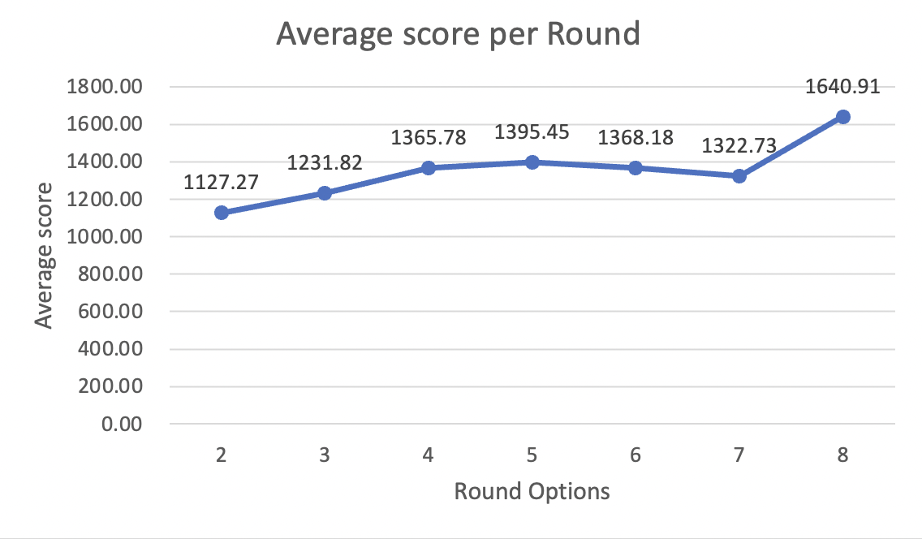

*Figure 38 – Average Score Each Round*

In this particular experiment, the biggest difficulty the user may encounter in the game is not facing seven rounds with different numbers of options, but how to get a higher score in these rounds, which is related to the number of effective moves the user makes in the game. To find out how effective users were in scoring points while playing the game, I also found out how many times a user ate an apple in each round using the shortest route, also known as an effective move. The graph below shows the relationship between the number of effective moves and the user engagement score.

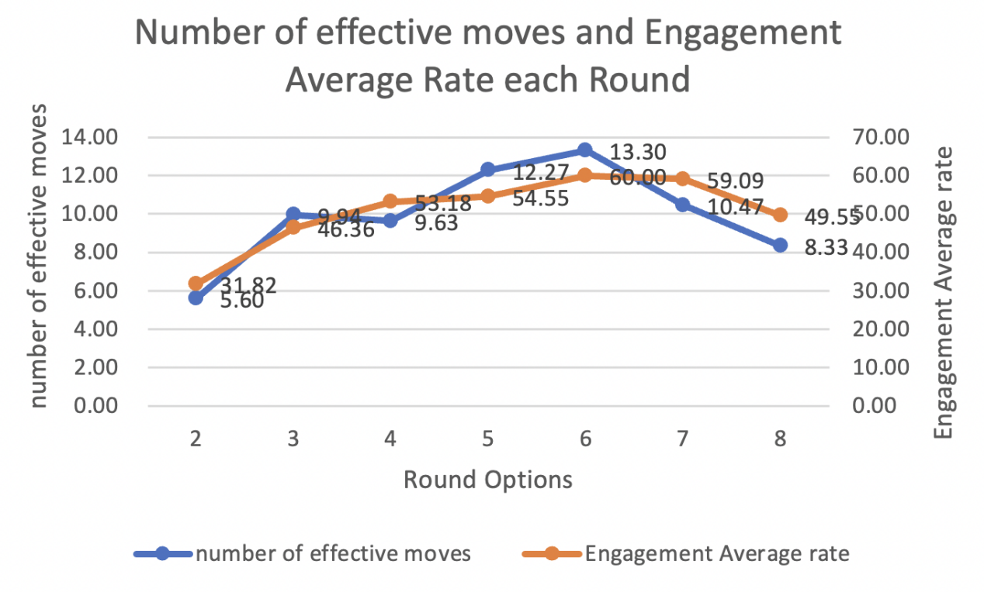

*Figure 39 – Number of effective moves and Engagement Average Rate Each Round*

The graph shows a positive correlation between the number of effective users moves and user engagement, suggesting that the more effective moves users make, the higher the engagement level. Users were not aware of how many effective moves they made during the experiment, but this may have subconsciously determined their experience of the game, and their experience rose when they controlled the snake to take the best route to eat the apple during the game, especially when the number of options was at 6, the average number of effective moves reached a maximum of 13.3, when user engagement was also at its highest. This suggests that the average number of effective moves also has a significant impact on engagement.

### 6.3 Additional Findings

The main study for this project was the relationship between user engagement and the number of options, but I found some additional findings based on the analysis of user feedback from the questionnaire. The questionnaire in the experiment asked users about their age, gender, how often they played the game and whether they had improved their skills during the game. Of these, as the participants in this experiment were all university students, I excluded age from the analysis of participation and made separate graphs of gender, frequency of play and whether skill improved in relation to changes in participation, which can be seen in the appendix H. These graphs are as follows:

* Trends in the change in participation per round by gender.
* Change in participation per round of play by frequency of play
* Trends in whether skill improves versus participation per round.

# 7. Project Conclusion

Overall, this project has been created to meet the aim of testing the theory of the game with a game platform.

It allowed the user to easily participate in the experiment, the game inspired by the snake game ran as planned, and all the relevant data needed was collected. There were some challenges in the implementation of the experiment, but I overcame them through constant learning and practice. I learnt a great deal of theory as I searched for background information on the game's engagement and options. I also honed my C# programming skills and my ability to apply my designs and ideas in Unity during the implementation process.

In general, this experiment was a success. It fulfilled the purpose of my experiment, which was to explore changes in player engagement through a game with an adjustable number of options. The experiment shows that players prefer to be offered more options, but only within a certain number, and when a certain number is reached, player engagement decreases again. This may be related to the fact that too few choices in a game can be boring, but too many choices can make the game out of the player's control. Based on this conclusion, I then analysed the possible reasons for this situation. In rounds with fewer choices, the user scores relatively slowly and efficiently, lacking the thrill of the game, but as the number of choices increases, so does the player's scoring efficiency, which leads to an increase in player engagement. However, when the number of options reached a number out of the player's control, the player's error rate in the game increased significantly, which led to a decrease in player engagement in the last two rounds compared to the previous rounds. In rounds with more options, players had more choices to make that allowed them to make the choice that would score most quickly. When too many of these options are added, players are likely to be unable to make the correct choice in a short period of time, the increased error rate brings about a decrease in experience, and their indecision makes scoring less efficient, affecting their enjoyment of scoring and making engagement less enjoyable.

In the present experiment, engagement peaked when players were offered six to seven options. This is in line with Sheena Iyengar's [17] theory that by reducing as many options as possible to six, people are more likely to make a choice. However, without testing this theory on more games or on different games, it is difficult to say whether this is just a coincidence.

Players' engagement changed according to the effective moves they made in each round, and as the number of effective moves increased, so did their engagement. As the number of options increased, although engagement increased and players felt they were given more freedom of choice, they did not use all those options because they could make better choices to increase the number of effective moves, but because the number of options was too large for them to make the best decision in a short period of time. Although they took more time to make their decisions, the average score (Figure 36) shows that the players still performed best in this round. This was because they were given more successful choices, which meant that they could find the line of movement that was not only successful but also the best for them.

In this project, the number of options changed player engagement to some extent, but in a strict sense, the number of options also changed the difficulty of the game and the complexity of each option. Although I have provided a brief analysis of the reasons why the number of options affects player engagement, more experimental and theoretical support is needed to demonstrate this.

In terms of results, my research and previous studies show that many options are correct, both in game play and in decision-making.[18] This research should be considered when designing games to provide players with the right choices and increase engagement.

### 7.1 Future Work

As a result of this experiment, I found a flaw. In this experiment, 8 options were the maximum for this game. This is because the player has absolute control over the snake in the snake game. They need to react immediately to the snake's direction at every moment it moves, which means they need a physical button to represent each direction of the snake. Still, too many buttons can be overwhelming, so I set a maximum of 8 options. Fortunately, the experiment results also showed that people's engagement was highest at 6 options and gradually decreased after that. However, feedback from players at the end of the game showed that they had difficulty finding the corresponding button in around with multiple options.

I will adjust how the user controls the snake by tweaking the handling so that the player can use the mouse or the joystick on the gamepad to control the snake to exclude the effect of too many buttons on the experiment.

In addition, the actual optimal number of options needs to be experimented with extensively in user testing as the game evolves to ensure the accuracy of the experiment. Suppose the player engagement curve is no longer as this experiment turned out to be in subsequent versions. The maximum number of options needs to be increased to see if people's engagement curve still drops as expected after more than 8 options.

# 8. References

[1] Newzoo (2017). 2017 Global Games Market Report: Trends, Insights, and Projections Toward 2020. Available at: http://progamedev.net/wp-content/uploads/2017/06/Newzoo_Global_Games_Market_Report_2017_Light.pdf (accessed February 16, 2018).

[2] Top Ten Qualities of a Good Video Game (no date) TheTopTens. Available at: <https://www.thetoptens.com/qualities-good-video-game/> (Accessed: 18 April 2022).

[3] Rusel DeMaria & Johnny L. Wilson (2003). High score!: the illustrated history of electronic games (2 ed.). McGraw-Hill Professional. p. 24. ISBN 0-07-223172-6. Retrieved April 7, 2011.

[4] More, James. "History of Nokia part 2: Snake | Nokia Conversations - The official Nokia Blog". January 20, 2009

[5] Conversations.nokia.com. Archived from the original on July 23, 2011. Retrieved November 4, 2011.

[6] Amy Jo Kim. “What makes games so engaging?” Medium. <https://amyjokim.medium.com/what-makes-games-so-engaging-2a06ca3eadf1,> accessed 30/10/2021

[7] Rozendaal, M.C. et al. (2009) ‘Game feature and expertise effects on experienced richness, control and engagement in game play’, AI & SOCIETY, 24(2), pp. 123–133. doi:[10.1007/s00146-009-0188-3](https://doi.org/10.1007/s00146-009-0188-3).

[8] Averill, JR.(1973) ‘Personal control over aversive stimuli and its relationship to stress.’ - PsycNET (no date) APA PsycNET. doi:[10.1037/h0034845](https://doi.org/10.1037/h0034845).

[9] Hustle (1977) (no date) MobyGames. Available at: <https://www.mobygames.com/game/hustle> (Accessed: 19 April 2022).

[10] Snake for Browser (2017) (no date) MobyGames. Available at: <https://www.mobygames.com/game/browser/snake> (Accessed: 19 April 2022).

[11]Hamiltonian path. Wikipedia, <https://en.wikipedia.org/wiki/Hamiltonian_path,> accessed 30/10/2021

[12] Thomas Hikaru Clark. Training a Snake Game AI: A Literature Review. Medium. <https://towardsdatascience.com/training-a-snake-game-ai-a-literature-review-1cdddcd1862f,> accessed 30/10/2021

[13] ‘Gaming keypad’ (2021) Wikipedia. Available at: https://en.wikipedia.org/w/index.php?title=Gaming_keypad&oldid=1053228404 (Accessed: 29 April 2022).

[14] Technologies U. (no date) *Programming and scripting with Unity | Unity*. Available at: <https://unity.com/solutions/programming> (Accessed: 19 April 2022).

[15] Technologies, U. (no date) *Unity - Scripting API: WWWForm*. Available at: <https://docs.unity3d.com/ScriptReference/WWWForm.html> (Accessed: 19 April 2022).

[16] Code Monkey (2019) *Making Snake in Unity: Food (Unity Tutorial for Beginners)*. Available at: <https://www.youtube.com/watch?v=6nw6IjHcMPY> (Accessed: 8 May 2022).

[17] Social psychologists Sheena Iyengar, PhD, and Mark Lepper, PhD (2000) ‘Journal of Personality and Social Psychology’, *Journal of Personality and Social Psychology (JPSP, Vol. 79, No. 6),* [Preprint].

[18] Megan Dove (2020) *An Experimental Environment to Test a Theory of Play.* University of Sussex.

# 9. Appendix

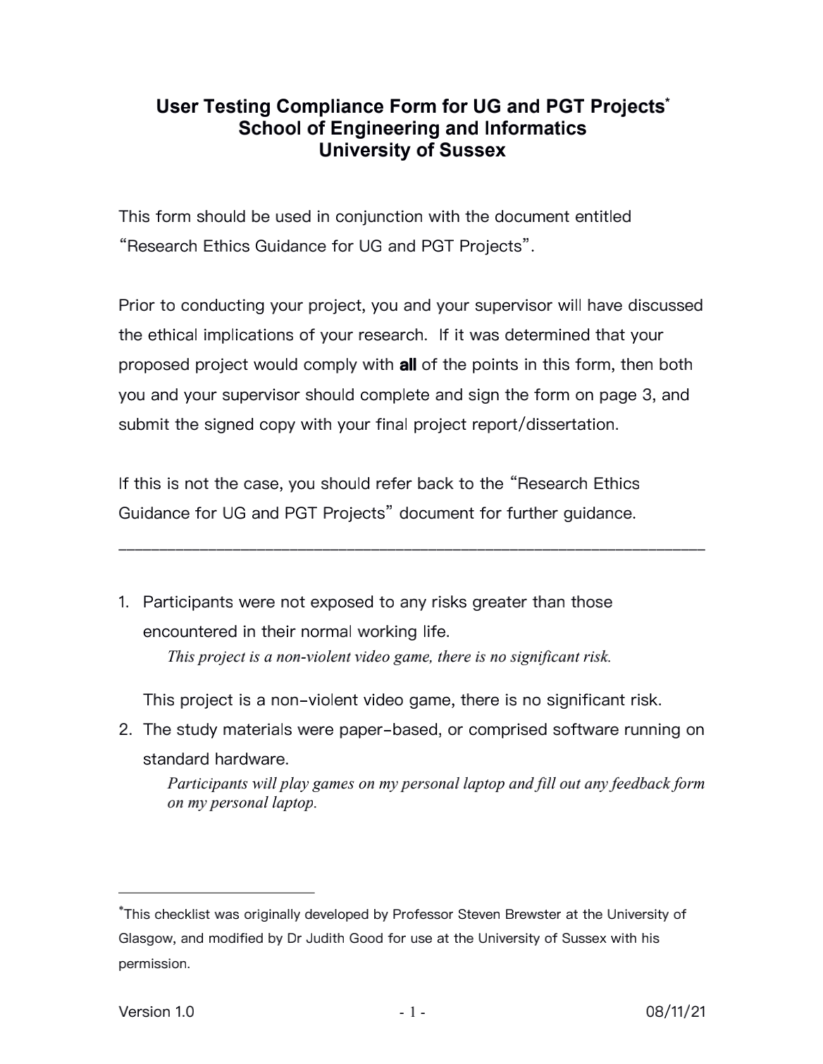**Appendix A -Ethical Compliance form**



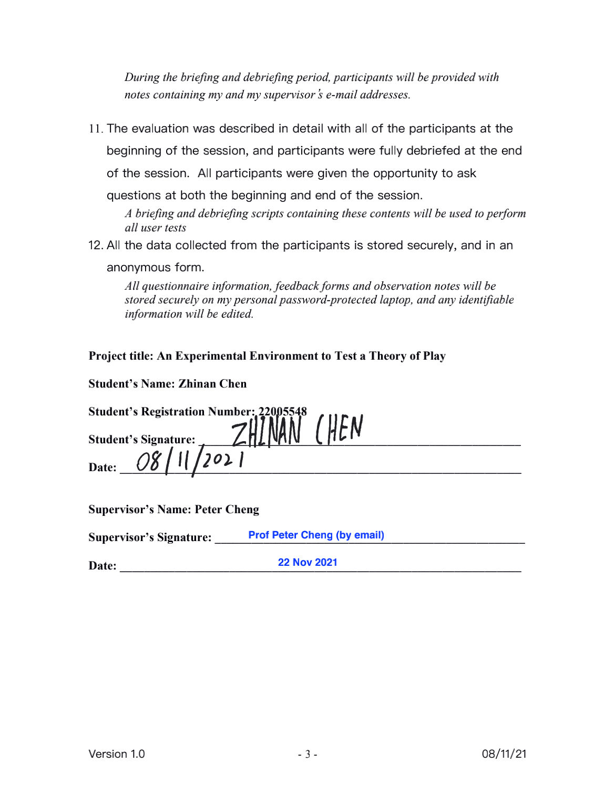

### Appendix B -User usability test feedback

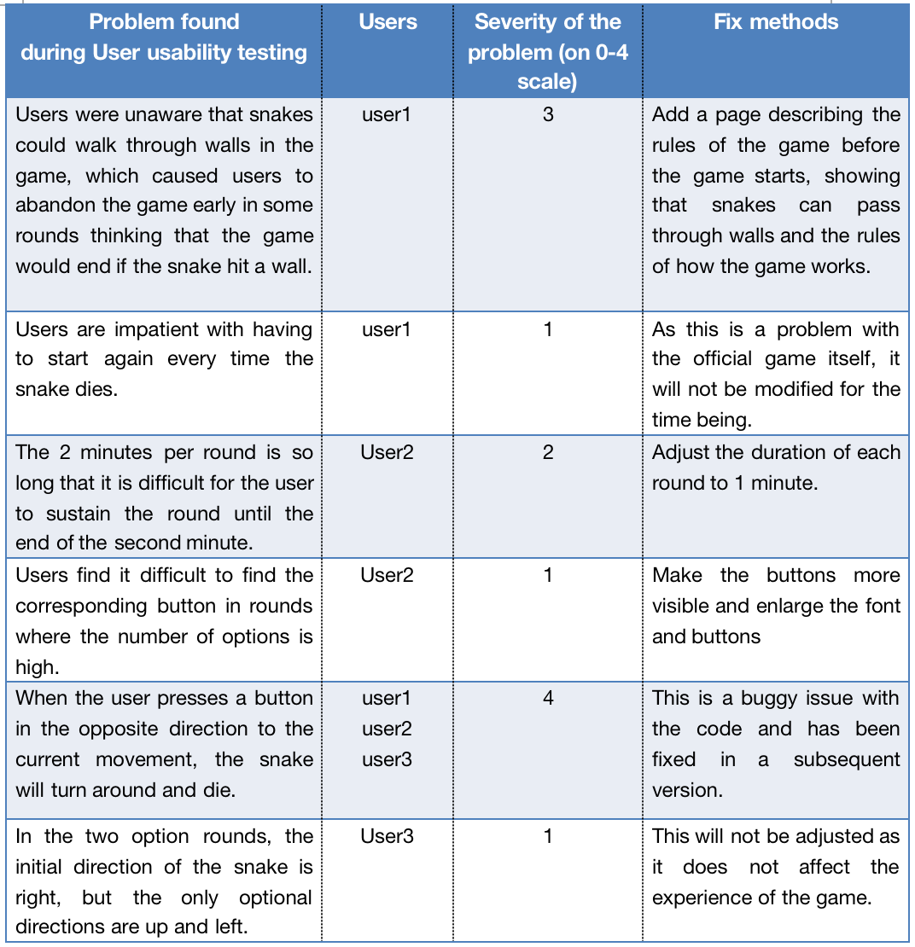

### Appendix C - Class Diagram

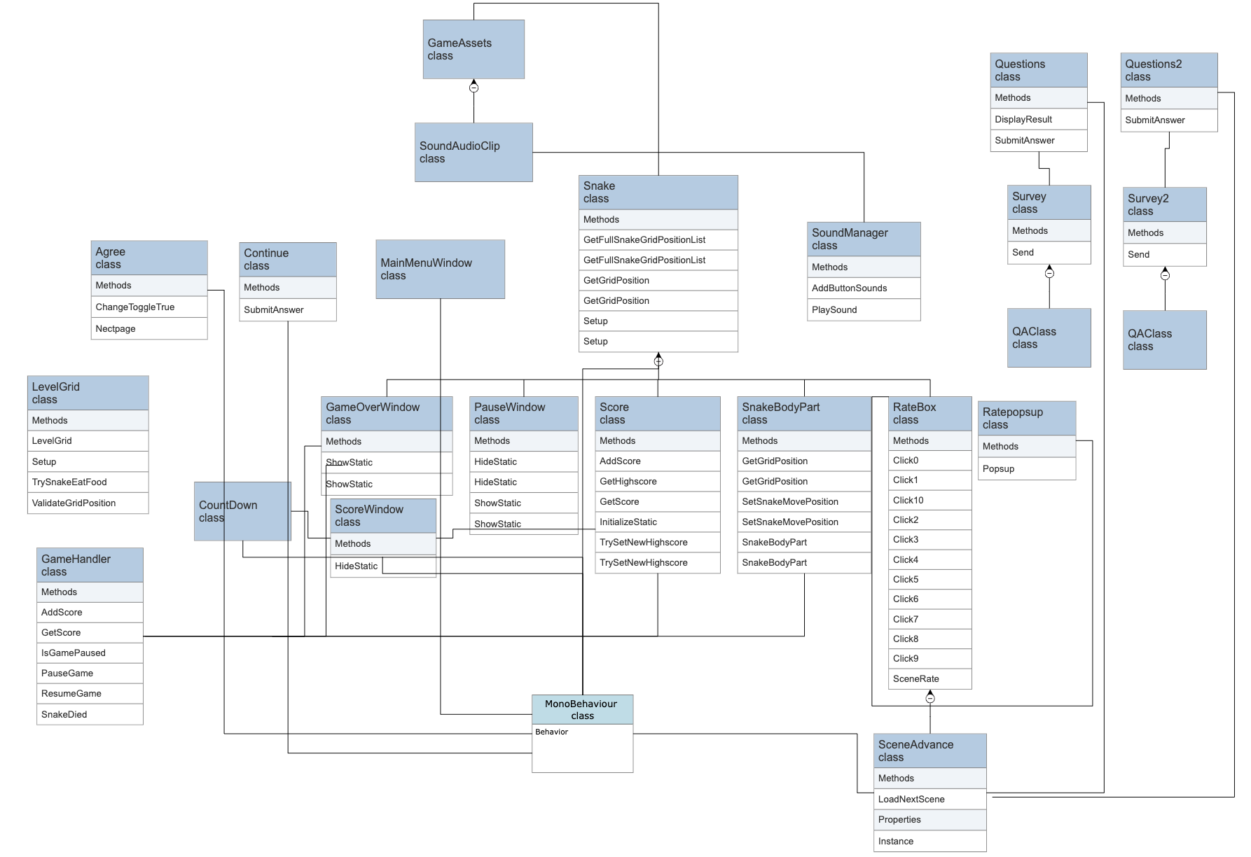

### Appendix D - Project Plan

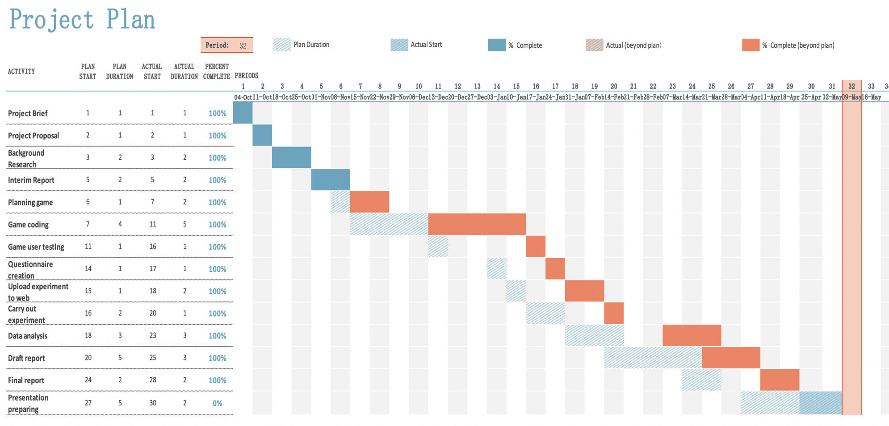

### Appendix E - Meeting Log

|  |  |
| --- | --- |
| Date | Discussed |
| 04/10/21 | In our first meeting, my supervisor talked over the basic information of the project (the credits occupied by the project and how long should it take to complete), told me where to find specific information about the project. |
| 11/10/21 | In this meeting, We discussed the subject of the project, the supervisor gave me some suggestions on the choice of experimental variables and programming tools. |
| 18/10/21 | Discussed the content of the interim report, including project proposals and ethical issues. The supervisor also reminded us to spend more time on user testing and data analysis. |
| 25/10/21 | In this meeting, the supervisor gave me feedback on the project proposal regarding the motivation and expansion of the project, and I revised the goal and expansion column in the proposal based on the suggestions. |
| 01/11/21 | Decide what level of ethical authorization I need and show how to apply for ethical authorization. |
| 08/11/21 | Confirmed the form of ethical issues, discussed the current progress of the project and the plan for the evolution of the project. |
| 15/11/21 | Discussed what to look for in a user testing compliance form based on my project, clarified the type of user testing and determined that the testing would not involve the collection of personal information. |
| 04/02/2022 | Demonstrated the development progress of my game prototype and shared my user testing plans with the supervisor. |
| 11/02/2022 | After asking my supervisor what changes needed to be made based on my game prototype, he suggested that user engagement checks should pop up within a set time frame and that the switching order of game scenes should be randomised. |
| 17/02/2022 | To discuss with the tutor the problems with the game demo, the specific questions are as follows.  1. The scoring window appears once in the first minute and once in the second minute for each level, each level is recorded twice, and each level has an equal play time: 2min. Different levels should appear randomly.  2. replace user names with user1 user2  3. the number of users in the user test should be at least 10  4. Record the keys pressed by the user and when they were pressed, prepare a questionnaire asking some basic information: when did you last play etc. |
| 25/02/2022 | I showed the supervisor a sample of the revised game and discussed that user testing would start in early March and end in mid-March and that it would be held online. |
| 04/03/2022 | I discussed with my supervisor that the content of the questionnaire for the testing session should be simple questions about basic user information and that later analysis of the user data should be numbered to facilitate the integration of the data. |
| 18/03/2022 | I presented the experimental data to my supervisor and analysed the direction of the data analysis as well as the results of the analysis. The mentor agreed with my analysis and pointed out how to present the results of the analysis in the report. |
| 25/03/2022 | The supervisor presented to us at the group meeting the content of the report write up plan that we needed to write before the holidays and needed to present to the supervisor at the next individual meeting. |
| 01/04/2022 | The tutor gave the following advice based on my Report writeup plan.  1. The introduction section should start with a background investigation, why the options were studied in relation to engagement, why the snake game was used and the motivation.  2. Refer to Magen's structure  3. when writing the fourth part of the implementation, add what difficulties were encountered and how they were solved  4. when analyzing the data, add why the 7 options will fall, why set the layout of the 7 options in this direction, discuss what will happen if the 7 options are missing other parts, will it go back to normal values.  5. add a graph to the data analysis to explore the relationship between the user's keystroke frequency (with the average number of steps it took to eat food) and engagement |
| 29/04/2022 | At the final individual meeting, my tutor gave comments and suggestions based on my draft report, and we discussed how to improve it to make it even better. |

### Appendix F -Original user questionnaire data

Please see Questioniare's sheet at experimental-data.xlsx

### Appendix G -Original user game data

Please see Game_data 's sheet at experimental-data.xlsx

### Appendix H - Additional finding graphs

Please see Additional' sheet in experimental Results.xlsx

### Appendix I - Debriefing Script

Hi,

I would appreciate it if you would like to participate in my snake game experiment for my final year project, which is going to be done on a PC or laptop, more details can be found on the instructions for playing page.

Here is the link to participate in the experiment:

[https://play.unity.com/mg/other/snake-webgl](https://play.unity.com/mg/other/snake-webgl%20)

Please accept my sincere thanks if you participated in this experiment!